Contents

1 – Business Picture 2

2 – Create the Project 6

3 – Project Structure 9

4 – “Program” Class 14

5 – “Startup” Class 16

6 – Environments 24

7 – GitHub - Source Control 26

2 – Set up Environment 27

3 – Installing Extensions 41

4 – Create the Project 45

5 – ASP.NET Core Characteristics 51

6 – Source Control 58

7 – Approach to Build this Project 61

8 – Architecture 64

9 – Domain Model 68

10 – Migrations 71

11 – Building our First APIs 84

12 – Common Runtime Errors 89

12 – Adding a New Angular Component 91

|  |
| --- |
| **1 – Business Picture** |

I’m building an application for a Vehicle Dealer called Vega. Let’s say you want to sell your car. You call Vega, talk to someone on the phone and ask them to register your car in their Database. Other people who are buyers, can browse the vehicles XXX’s Database, and if they are interested, they can call and talk to someone on the phone and the rest on the process happens offline at that stage.



As part of recording a vehicle for sale, we need to know this info about the vehicle:

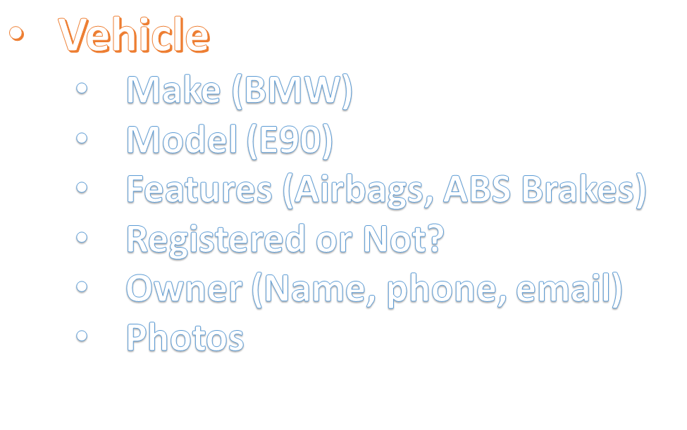

So, basically there are a sort of standard features, like Airbags. Here we have a many-to-many relationship between vehicles and features:

A vehicle can have many features and a feature may be available for use in many vehicles.

The simplest solution to this problem is to have a page where we see all the vehicles in the Database. If there are more than 10 vehicles, we should display them in pages. From this page we should be able to click a vehicle to see its details.

We should also have a page to add a new vehicle to the Database.

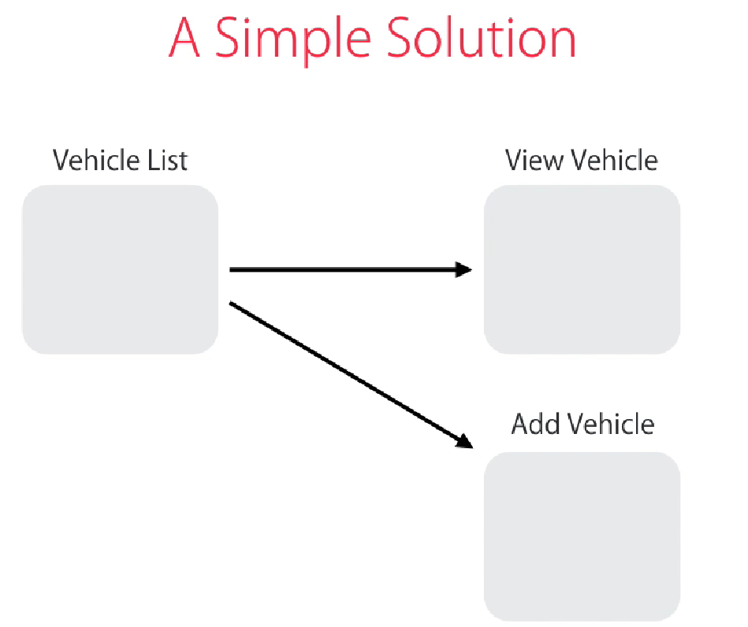

Also, in terms of Authorization, we need two different roles: **Moderator** and **Admin**. Moderators are Vega personnel who talk to customer over the phone. Admin is the Administrator of the system with additional privileges.

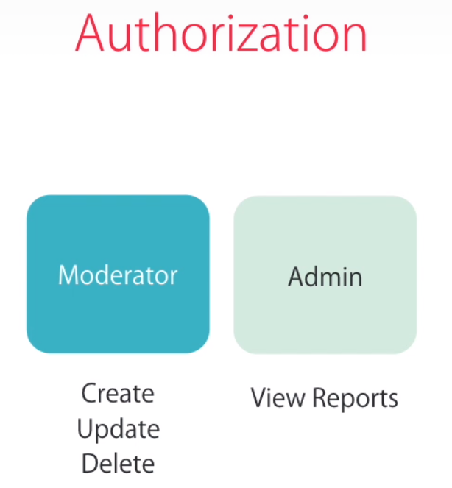

For this app, we’re going to display a report of vehicle sales by their Makes in a pie chart like this:

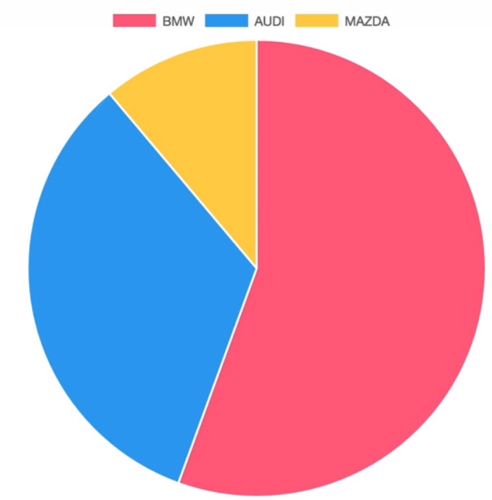

Anyone with Admin role can view this report.

Finally, if someone hasn’t logged in, they should only be able to browse the vehicles. So, we’re going to hide the buttons for creating, updating or deleting vehicles.

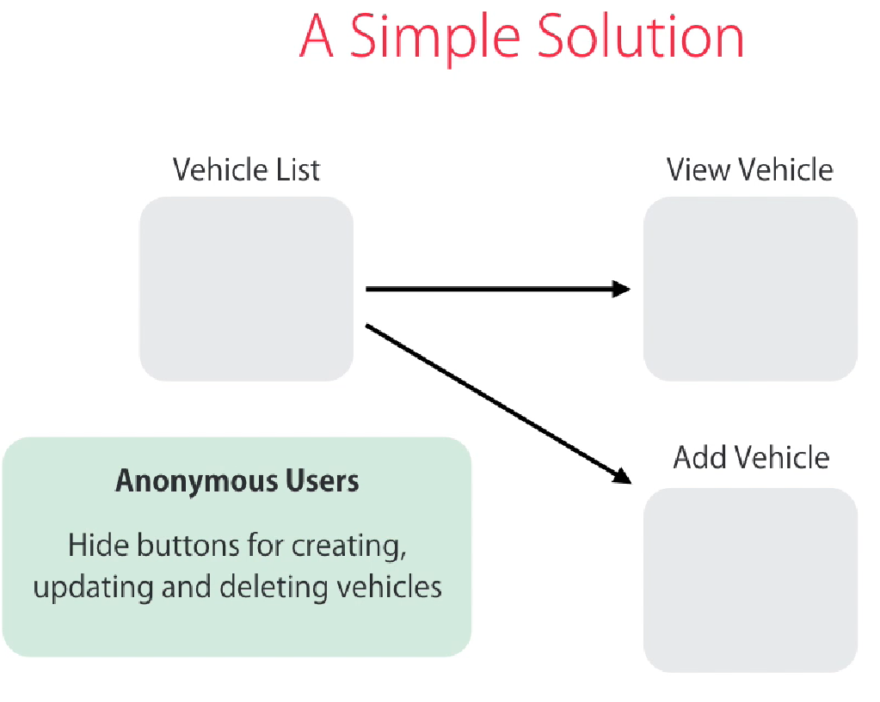

For this project we’re going to use:

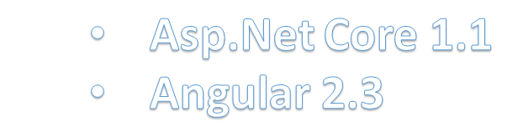

|  |
| --- |
| **2 – Create the Project** |

In Visual Studio, create a new project:

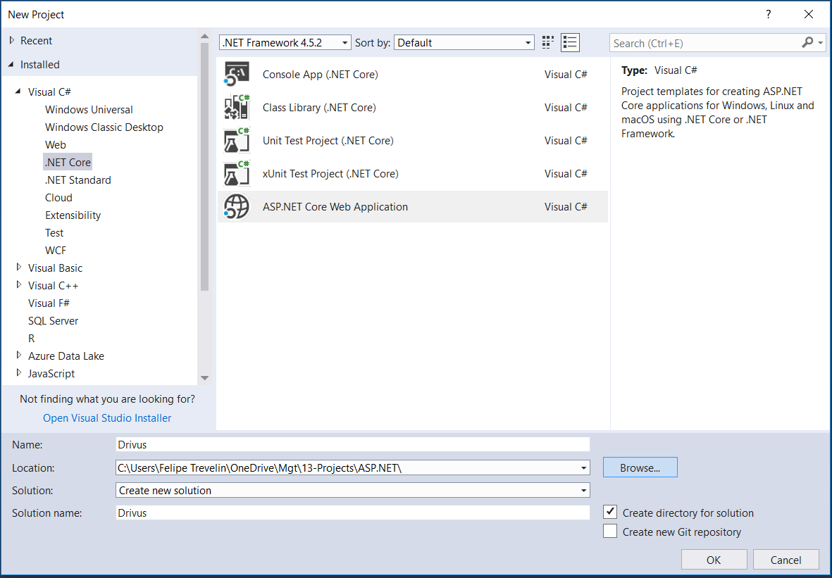

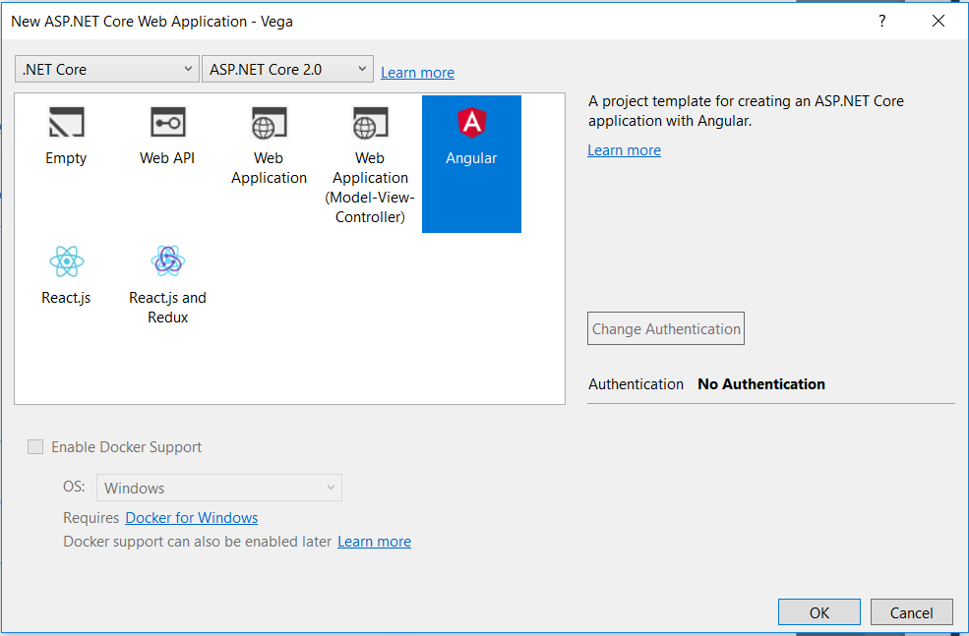

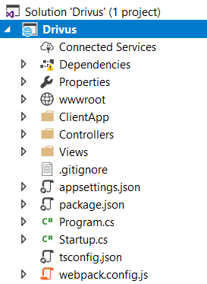

Just before the final release of Visual Studio 2017, Microsoft introduced a new project type, which uses a JSON file called **project.json**. They were working on this as a replacement for .**csproj** files. That is because **csproj** was very complicated and heavy whereas this **project.json** is very clean, lightweight and consistent with other frameworks.

However, in the final release of Visual Studio 2017, Microsoft decided drop project.json and go back to those .**csproj** files.

If you run your app, that’s what you get:

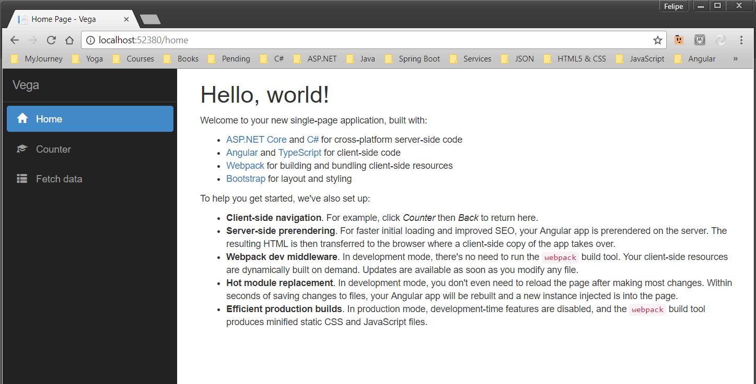

|  |
| --- |
| **3 – Project Structure** |

Let’s quickly explore what we have in this project structure:

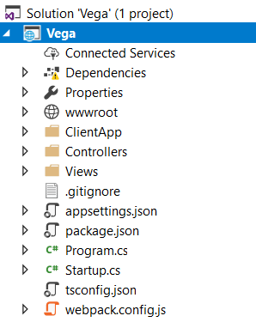

**ClientApp**: this is where we have the client-side code, that is, the Angular app.

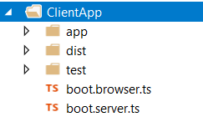

We have “**app**” folder, which has inside the “app.module”, “components”, exactly like other Angular applications:

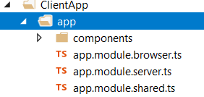

We also have **Controllers** and **Views**, which belong to Asp.Net Core, exactly like Asp.Net MVC 5.

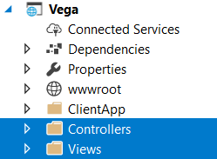

We have a new folder “**wwwroot**” and this is where we insert the public assets of our application for the client side.

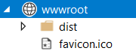

You’ll have inside of it the icon of our application (**favicon.ico**), and we also have folder “**dist**” which contains a couple of JavaScript files. One of them is called “**main-client**” and it is the compilation of our Angular Application into JavaScript. We also have “**vendor.js**”, which is the compilation of all the third-party libraries you’re using. Similarly, we have “**vendor.css**” which is a compilation of al third-party stylesheets in this project.

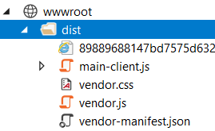

So, in your applications, you need to insert the public assets inside this “**wwwroot**” folder. That includes any images, fonts, icons and so on.

We have “**appsettings.json**”. In Asp.Net Core, this is where we store our application settings. In the previous version, we used **Web.config** file to do that.

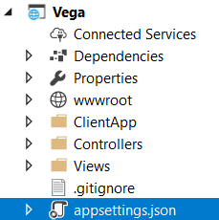

We have a couple of new files in our project structure, in comparison with previous versions of Asp.Net:

They are “**Program.cs**” and “**Startup.cs**”.

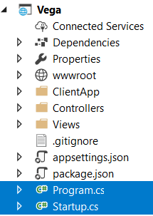

Startup file is where our application starts.

Also, we have “**webpack.config.js**” which is a bundler for client-side code, so it can compile and minify of our JavaScript and Stylesheet files. In this file we’re basic telling Webpack where our source files are, how they should be processed, and where they should be stored.

For the most part you don’t need to modify it, but sometimes in some projects, you may need to modify this configuration.

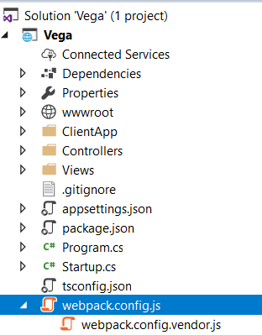

Finally, we have “**webpack.config.vendor.js**”. In this file we have the configuration for compiling all the third-party libraries.

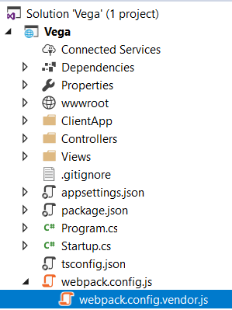

|  |
| --- |
| **4 – “Program” Class** |

Like in Console applications, in **ASP.NET Core** we have a class called “**Program**” with a method called “**Main**”, which is the entry point to our application. ASP.NET Core applications are similar to Console applications in that regard:

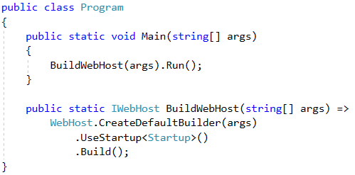

Over these few lines, we’re configuring and running a web server to host our application. In Asp.Net Core 2.0, Microsoft introduced a helper method “CreateDefaultBuilder”, which encapsulates pre-configuration defaults for your program. The following defaults are applied:

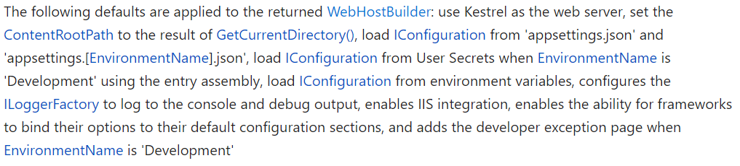

This is the helper method CreateDefaultBuilder:

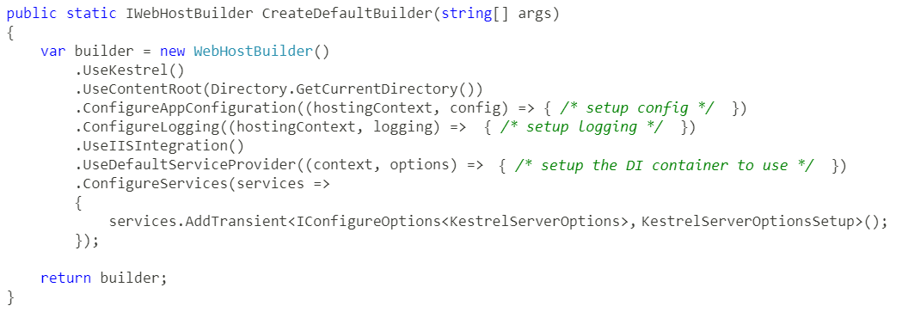

ASP.NET Core comes with two in-process HTTP Server implementation:

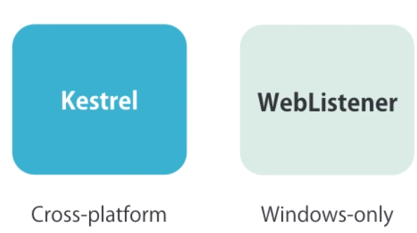

Kestrel, which is a new web server, can run on Mac, Windows, Linux. it doesn’t have all the features of IIS, or Apache. It’s not very secure, but it’s good enough to be used in an internal network. So, if you’re building an application for internal use, you can use Kestrel. But, for a public-facing website, you need to put Kestrel behind IIS on Windows, or Apache on Linux.

WebListener, on the other hand, is only for Windows.

Kestrel is set as the default web server for your application in the helper method “CreateDefaultBuilder”, which you have seen above.

|  |
| --- |
| **5 – “Startup” Class** |

In the “Startup” class we have two methods that are automatically called at runtinme:

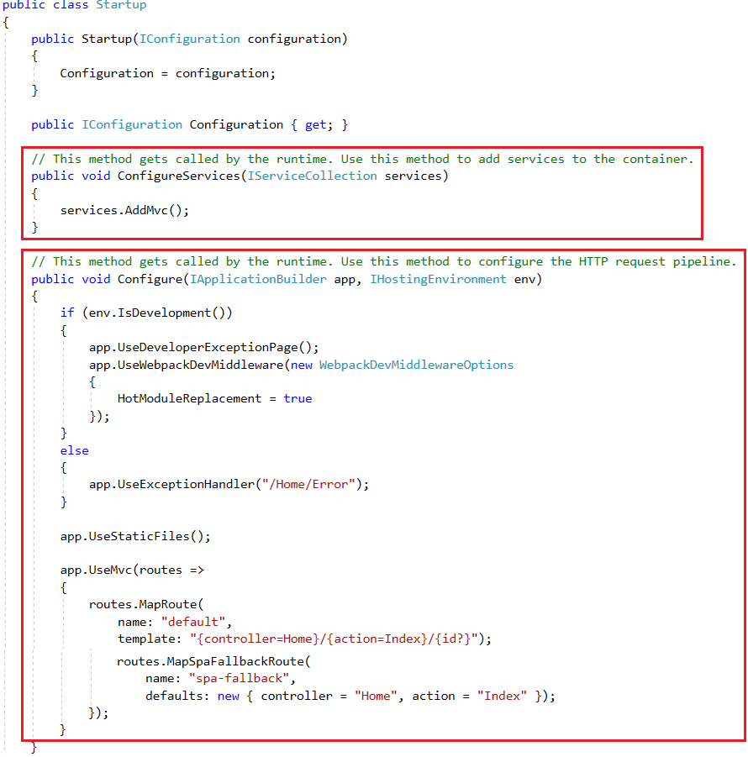

Methods description:

* **ConfigureServices**: it is used for Dependency Injection. In Asp.Net Core, if our Controllers have dependencies that should be provided in their constructor, we need to register them in this method:

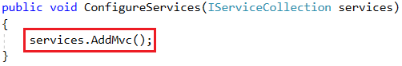

So, this method has a parameter or type IServiceCollection which is a container for all the dependencies in our application. In this method, this is how register your dependencies:

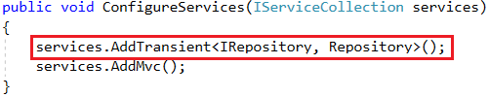

IRepository is an interface and **Repository** is an implementation of it. Then, anywhere in our application, if we have IRepository in the constructor of a class, the runtime will create an instance of the **Repository** class and inject it into that class. This is basically Dependency Injection.

Regarding the second line of this method (**services.AddMvc()**), if you look at the implementation of this method, you’ll find a bunch of statements like the one you entered above, for dependency injection. When you call this method, it registers a bunch of interfaces and their implementation that are part of Asp.Net MVC or Asp.Net Core itself.

* **Configure**: in this method, we configure the Request Processing Pipeline, which is detailed below:

**Request Processing Pipeline**

When a request comes in as web server, imagine it goes through a pipeline:

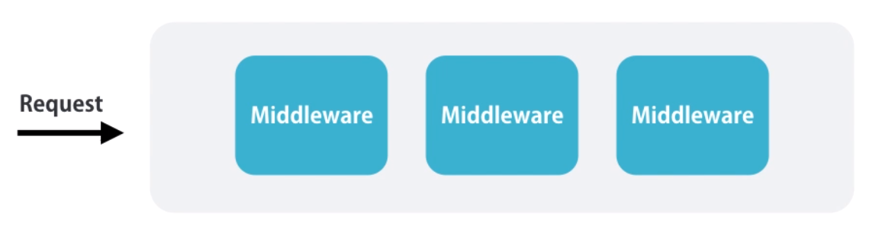

In this pipeline, there are multiple components which we call Middleware. Each Middleware is like a function. It looks at the incoming requests and if interested in that request, it will do something with it. Otherwise, it just skips. The previous version of ASP.NET, in ASP.NET MVC 5, our request processing pipeline was fairly heavy weight. And we didn’t have control over configuring these Middleware. In ASP.NET Core, we can customize this request processing pipeline and add only the Middleware that we need. This way, we can improve the performance of our application, because CPU Resources are not wasted for Middleware that we don’t need.

Let’s take a look at a few examples:

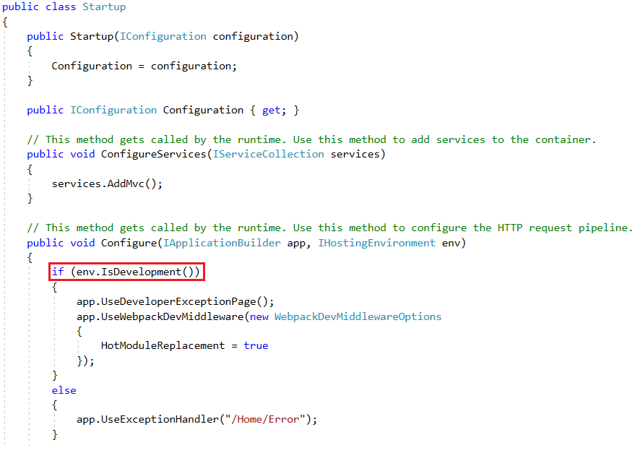

Here, if **Environment (env)** is equal to **Development**, we add a couple of Middleware:

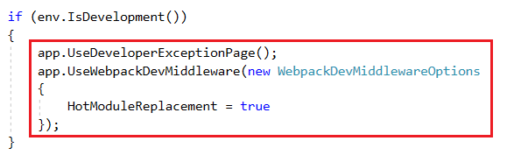

One is “**DeveloperExceptionPage**” which renders an exception with all its details and the other is “**WebPackDevMiddleware**” which will automatically compile JavaScript, CSS and typescript code if we make any changes to that and push the changes to the browser, so we don’t even need to reload the page. This is called “**HotModuleReplacement**”. These two Middlewares are only used in the development environment. We don’t want that in production.

Here’s another Middleware:

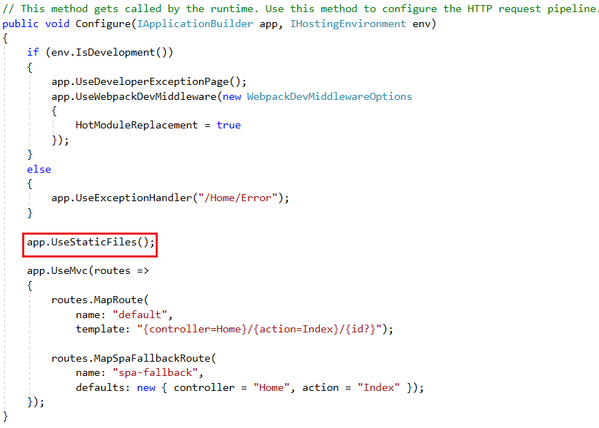

With this, we’ll be able to serve static files like images, stylesheets and so on. If you comment out line, we won’t be able to serve any images or stylesheets to our application. And this is a Middleware that every ASP.NET needs.

Finally, the last Middleware is Mvc (UseMvc):

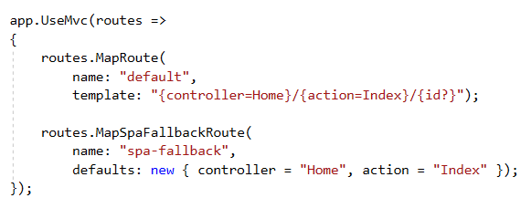

MVC is nothing but a Middleware. When a request comes in, this Middleware looks at the request and based on our routes, it will forward it to an Action and a Controller. That’s MVC.

In order to test **HotModuleReplacement**, run your application, access “Fetch data” and click console:

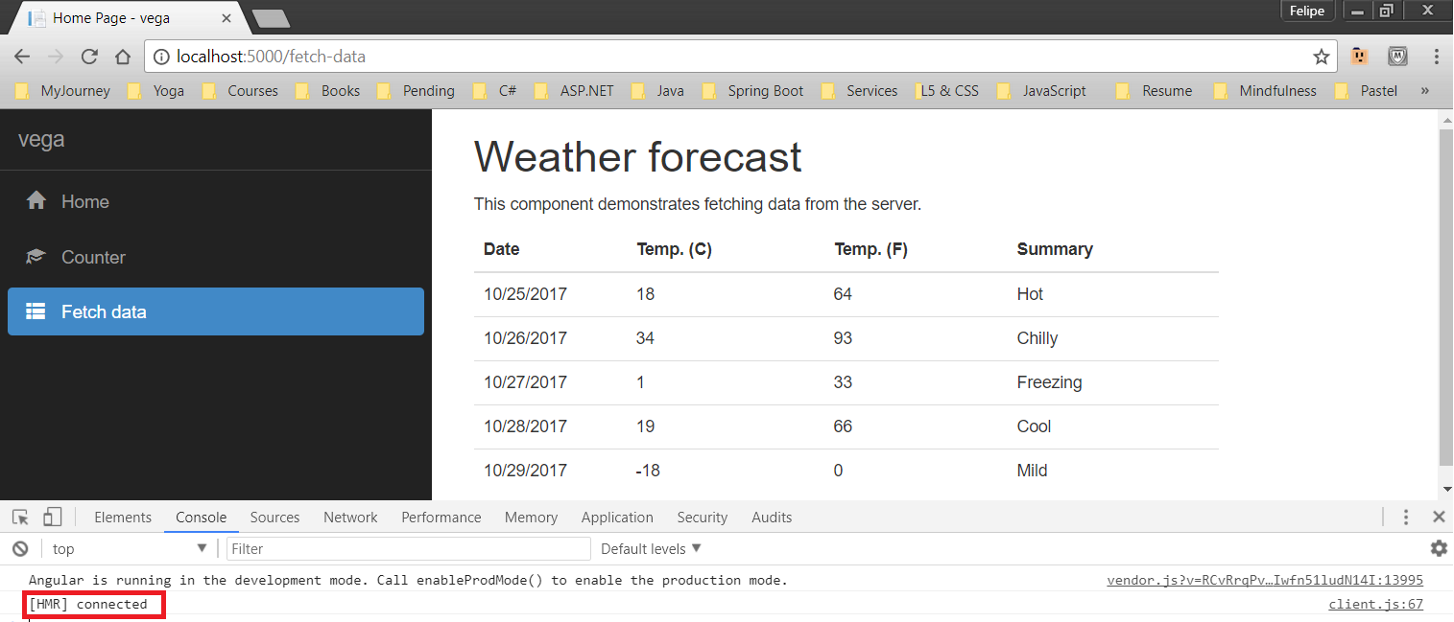

You will find this message called [HMR] which stands for **HotModuleReplacement**. If your machine is configured as the Staging or Production Environment, you’re not going to see this message, because this Middleware is set exclusively to Development.

Now, if you access the HTML file that holds this view and make the following changes:

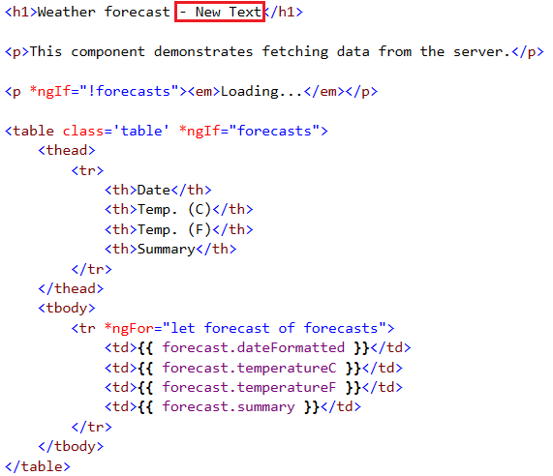

If you save, find that your webpage is updated without the need to reload it:

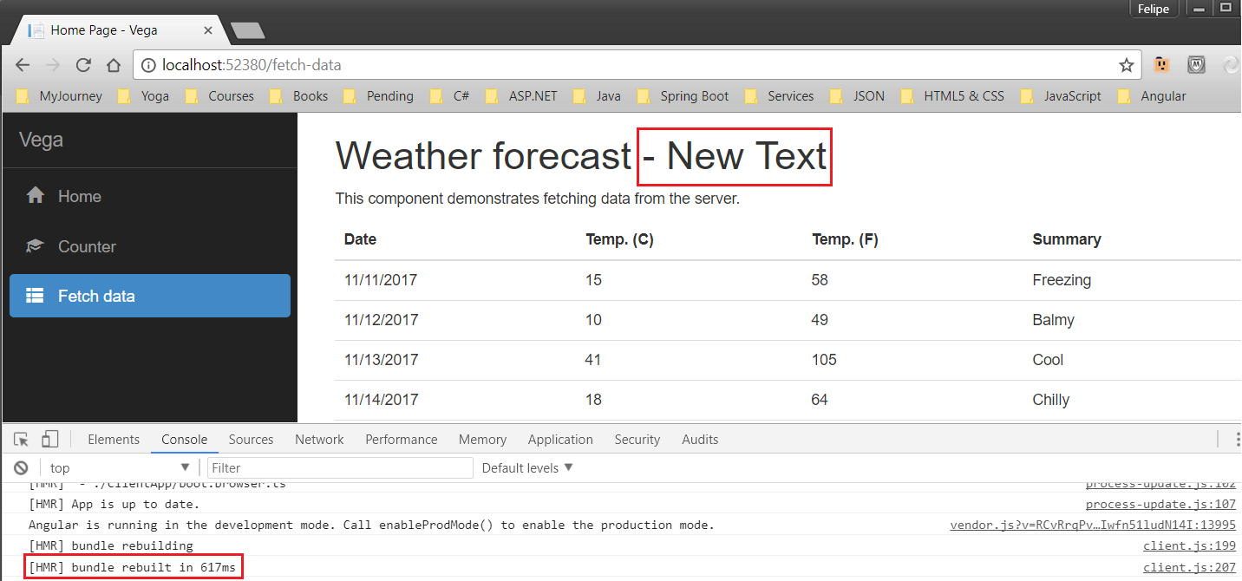

Also, in the console tab you can see that WebPack rebuilt our bundle. Below that, you can see the updated modules, that is, the modules that were affected by the change you’ve made. So, with WebPackDevMiddleware, anytime you modify you **client-side code**, assuming you are in the development environment, changes are automatically pushed to the browser.

When it comes to server-side code, when you use IIS Express to start your app, any changes made to it are recompiled automatically. For example, suppose you’ve run your app and have the page open:

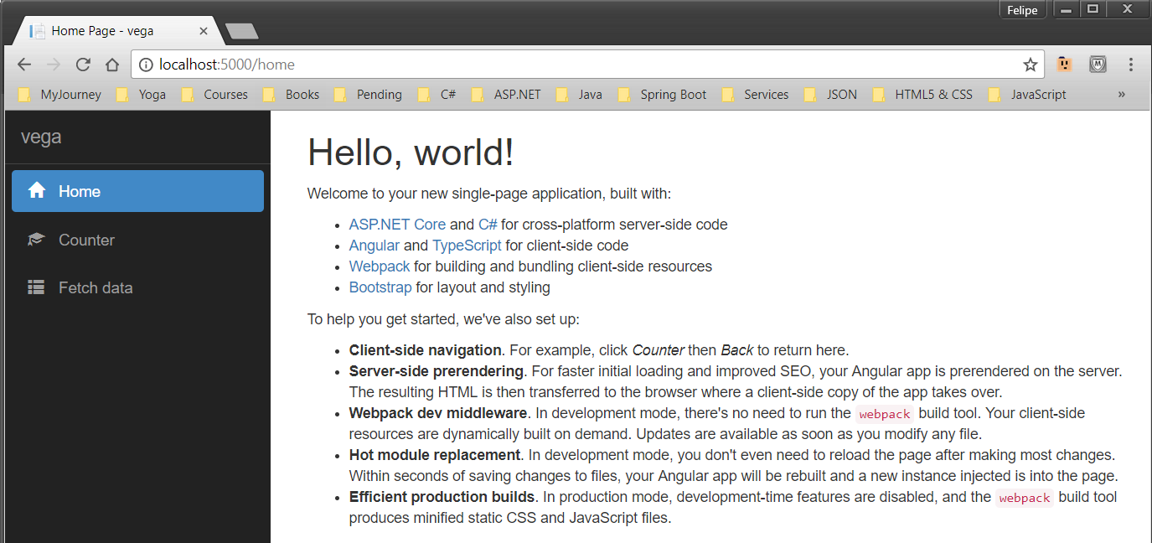

Now if you access HomeController and enter an exception in the “**Index**” action:

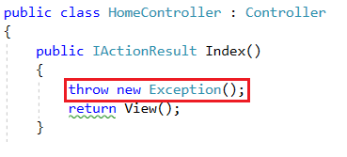

If you save, open the same page you had and press F5 to reload, you get this:

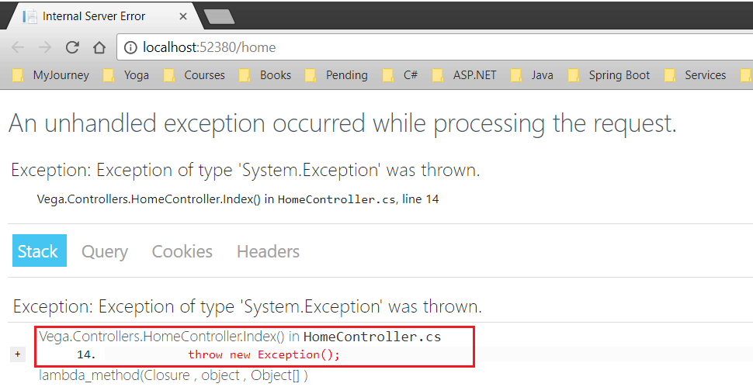

That is because your using this to launch your app:

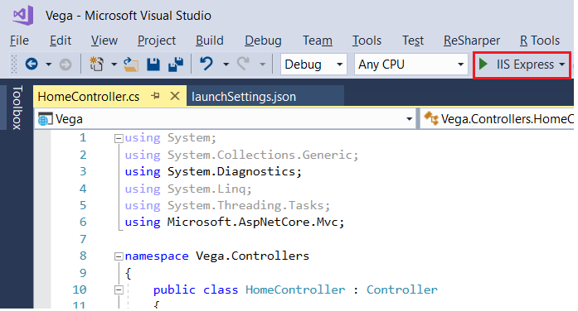

This is configured in file “launchSettings.json”:

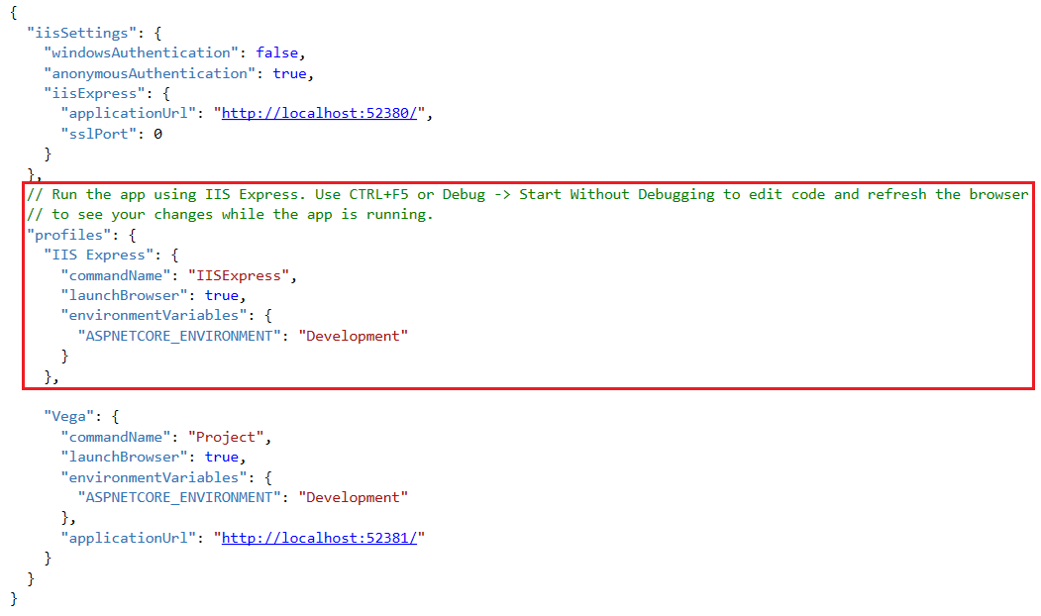

|  |
| --- |
| **6 – Environments** |

In ASP.NET Core, we have this concept of environments. We have Development environment, Staging and Production.

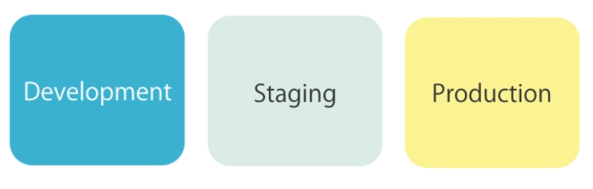

In ASP.NET MVC 5 we don’t really have this concept built into the framework and we had to do some tricks to “Web.config” to implement this.

If you're using Visual Studio, the environment can be configured in your project's debug profiles. Debug profiles specify the [server](https://docs.microsoft.com/en-us/aspnet/core/fundamentals/servers/index) to use when launching the application and any environment variables to be set. Your project can have multiple debug profiles that set environment variables differently. You manage these profiles by using the **Debug** tab of your web application project's **Properties** menu. The values you set in project properties are persisted in the *launchSettings.json* file, and you can also configure profiles by editing that file directly.

In Visual Studio, in order to configure the ***Environments for IIS Express***, access your project’s properties:

**Project 🡪 Vega Project 🡪 Debug**

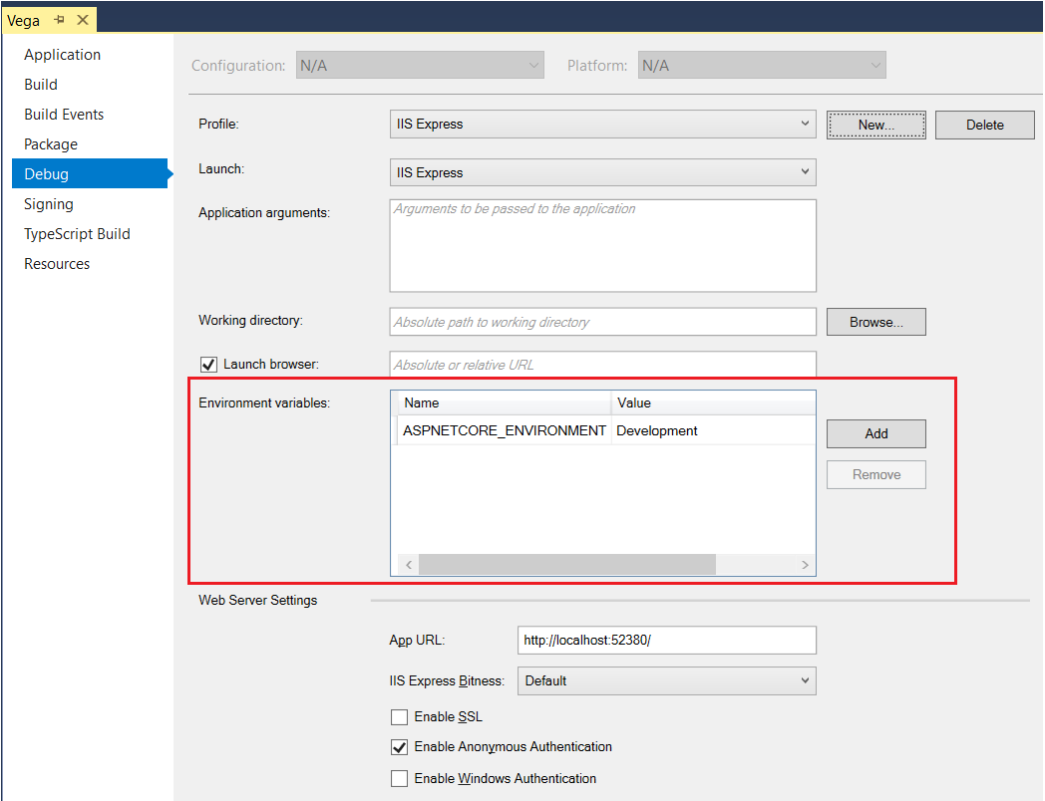

You can have **Development**, **Staging** and **Production** as values.

If you take a look at file “launchSettings.json” under folder “Properties”, you will see:

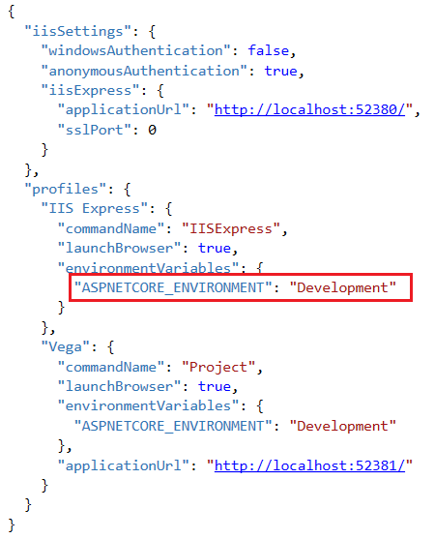

Depending on which value you set at the Debug Environment Variable, it will update this field above.

|  |
| --- |
| **7 – GitHub - Source Control** |

There is a bunch of ways to use Git tool for Visual Studio.

The first thing we have to do is to create a repository in GitHub website linked with our GitHub account. A repository is just a folder that ins going to exist both remotely and on your local computer. So, it’s going to be a folder in your computer that you’re probably going to have a lot of different programs in, for example, a Web Development Repository where I have tons of code in it. At the same time, some people might want to have one repository per program. It doesn’t really matter. The important thing to understand here is that ***a repository is just a folder on your computer that you can synchronize with a folder on the GitHub server***.

The first step when working with GitHub is creating your remote repository on GitHub website. On GitHub website, click “New Repository”:

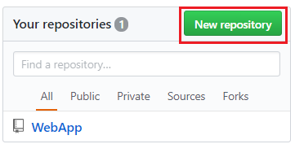

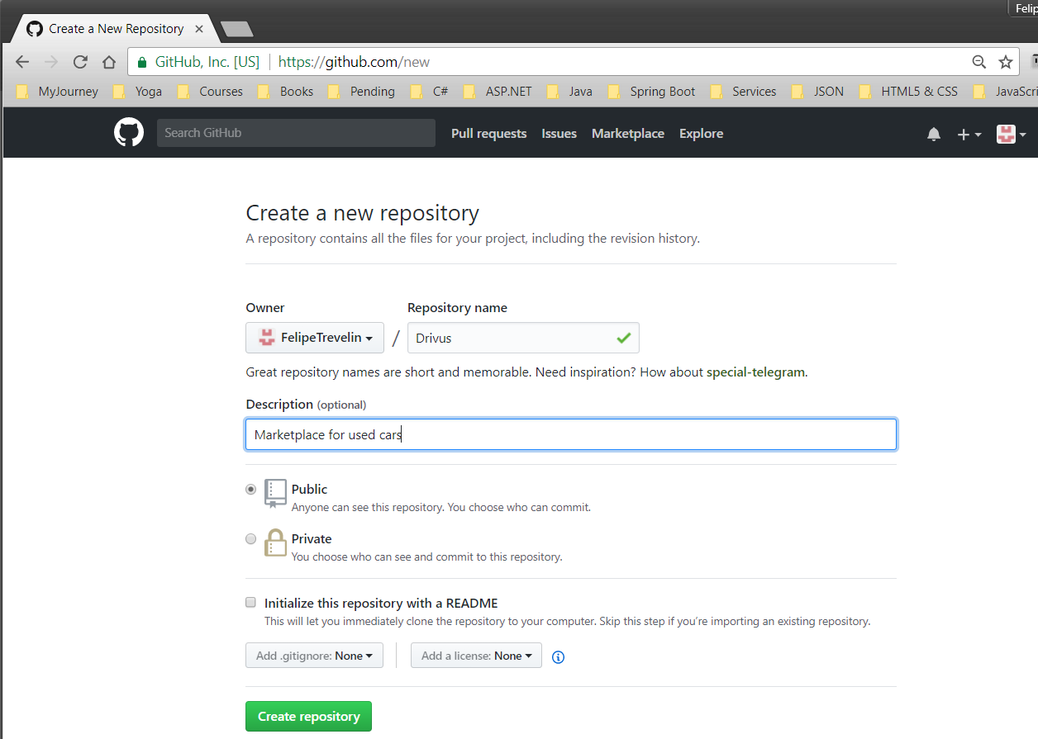

This is the URL that represents the remote folder that will contain all your code.

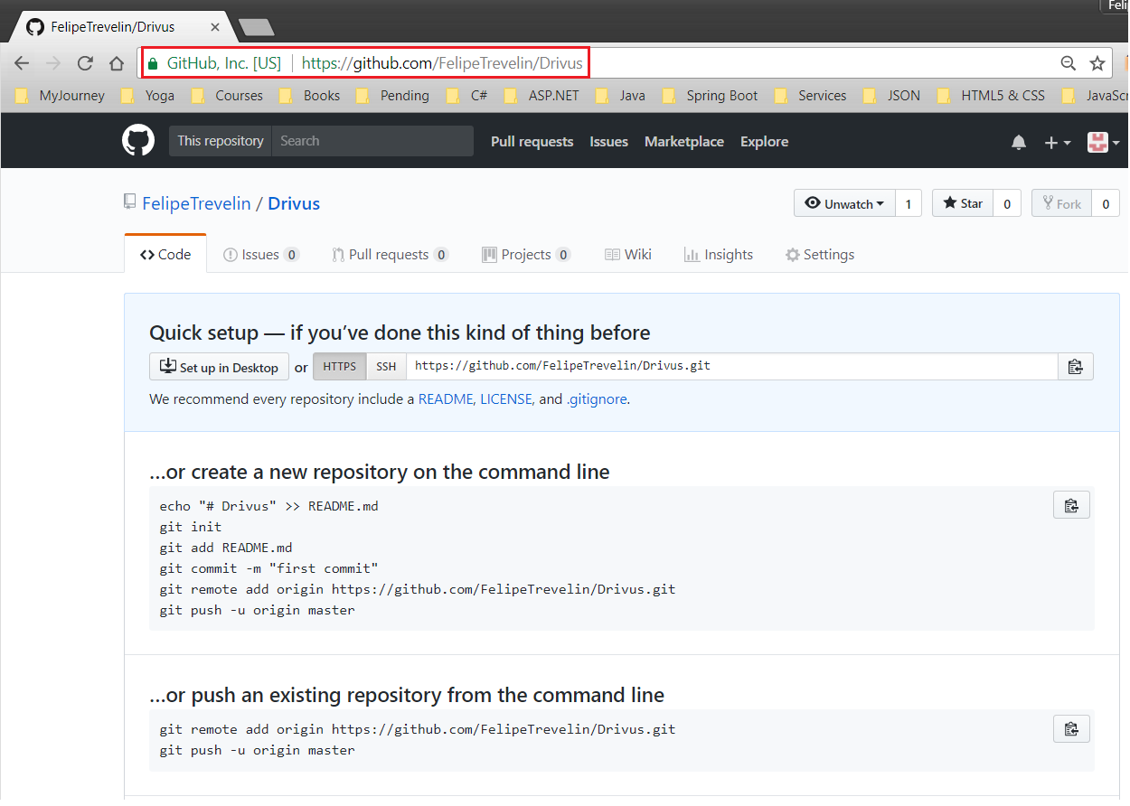

Now, for the second step, we need to create the local folder which we want to synchronize with GitHub folder and be a mirror of it, so we can work on our project in the local folder and continually push changes to the remote folder.

You have many options here. You can create an empty folder and later on create a new project inside that folder. Or you may create the project and then use the folder that the project created as the local repository.

Since I have already created my project, I’ll use that as the repository:

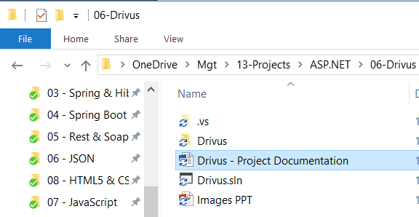

Let’s now access Visual Studio and click on View🡪Team:

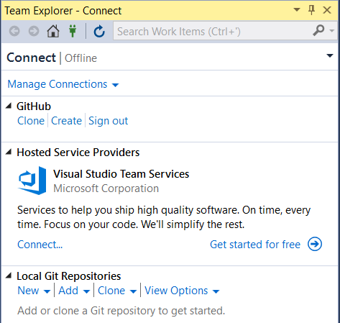

Click option “Home”:

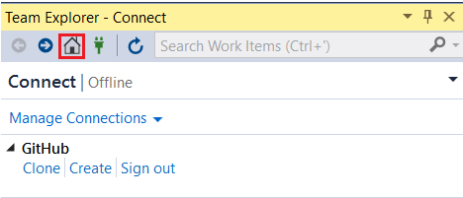

Click option “Settings”:

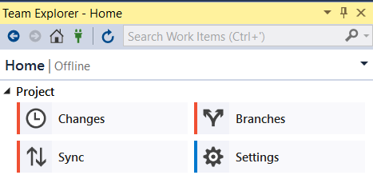

Click option “Global Settings”:

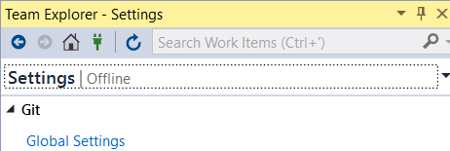

The first thing is to make sure your global settings are all correct:

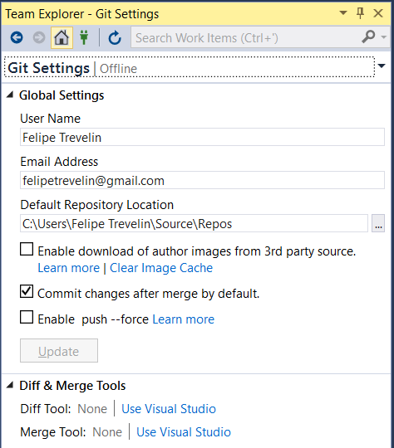

Click option “Manage Connections”:

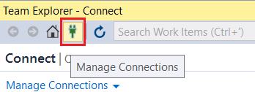

|  |
| --- |
| **2 – Set up Environment** |

In this project, I’m using Visual Studio Code (also called VS Code), which is a source code editor developed by Microsoft for Windows, Linus and macOS. It is a very lightweight and fast editor. It’s not a full IDE like Visual Studio, but it’s a very powerful cross-platform code editor.

**.NET Core SDK**

If you used Visual Studio, there would be no need to download .NET Core, but we’re not in this position. SO, to start with, download **.NET Core SDK** via URL <http://microsoft.com/net/core>:

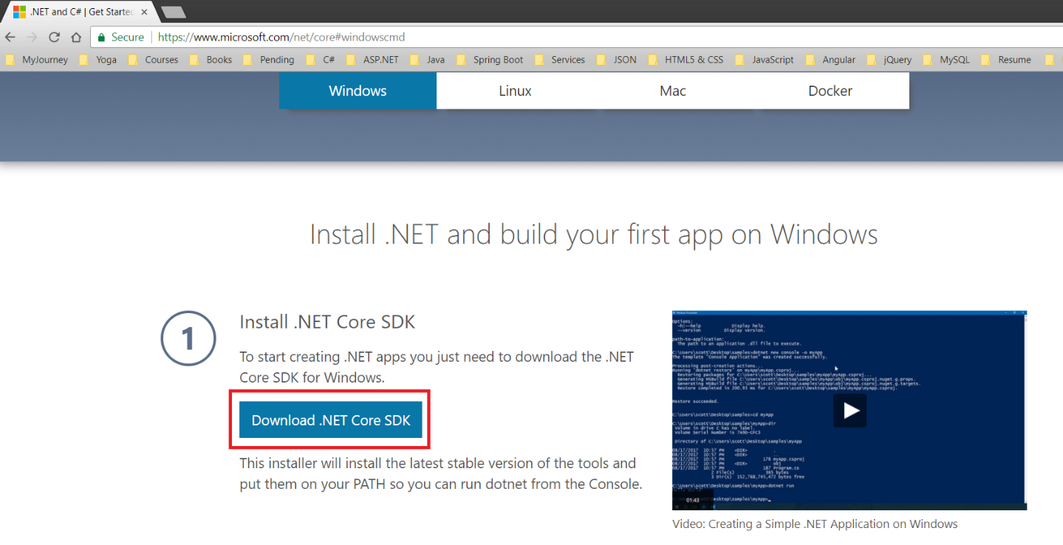

**Visual Studio Code**

Now, download Visual Studio Code via URL <http://code.visualstudio.com>:

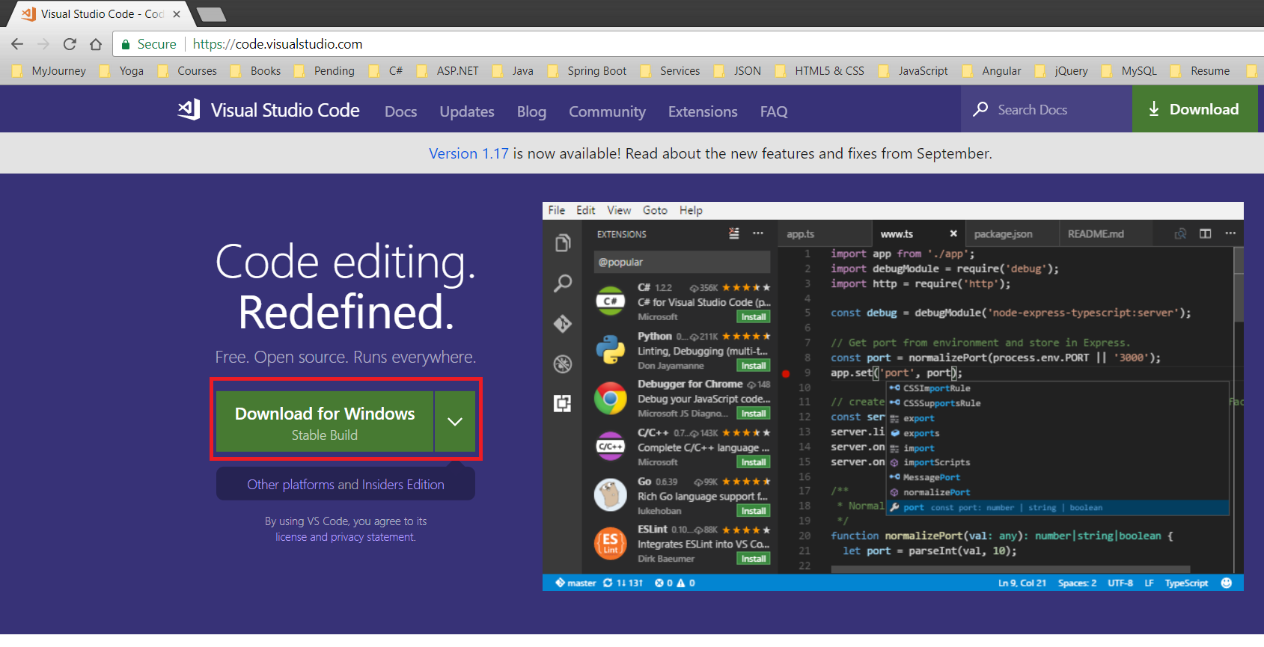

You should now be able to access your new code editor:

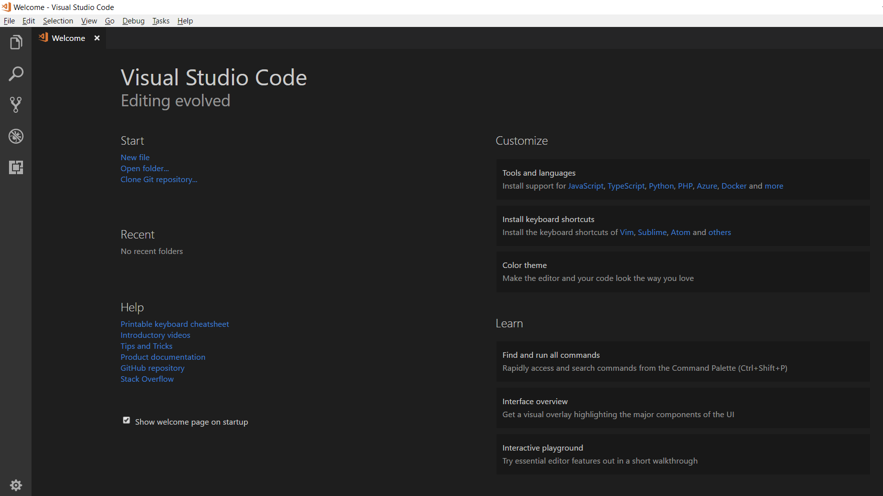

**NodeJs**

Now, access website <http://nodejs.org>:

Click button 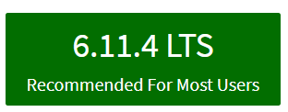 to install **NodeJs**

After downloading it, install it in your machine.

**Entity Framework**

Now, you need to install Entity Framework Core, so we can integrate our project with a Database. These steps will add an entry to the **csproj** file.

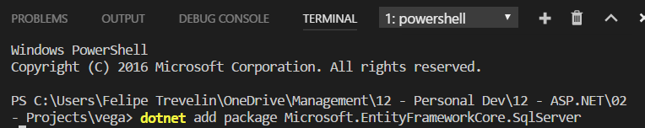

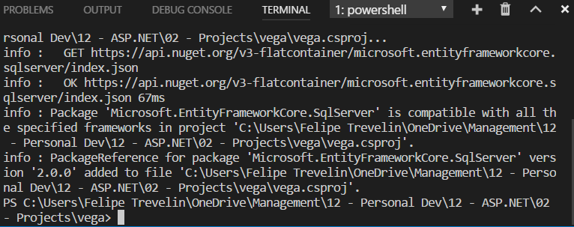

You also need to install Entity Framework Design:

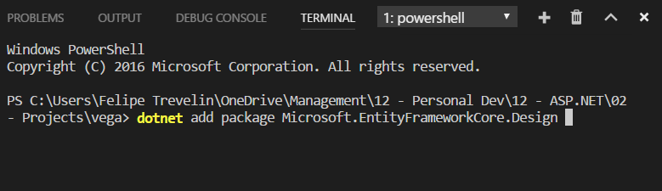

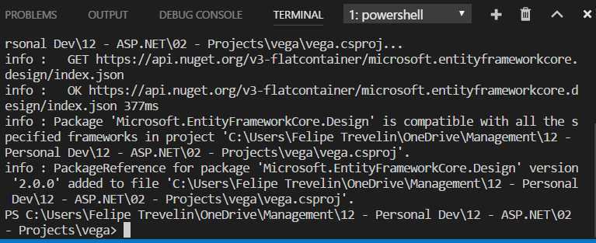

Because you were using Visual Studio Code, you needed to execute “**dotnet restore**” so that system downloads the packages that were just added to file **csproj**:

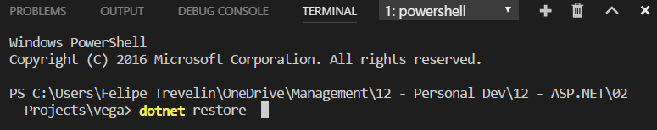

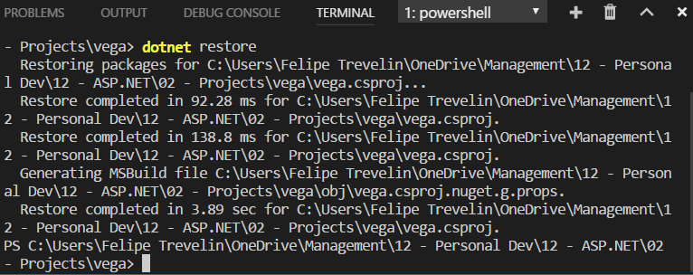

If you are using Visual Studio, it’s a bit different from the steps above. Use the following command in Package Manager Console:

**Install-Package <PackageName>**

Also, in order to create migrations and update the database, you need to install Entity Framework commands. We use these commands to create migrations and update the database. These commands are not installed by default and you need to install them manually by editing the **csproj** file.

If you’re using Visual Studio, add the following code snipped on the top:

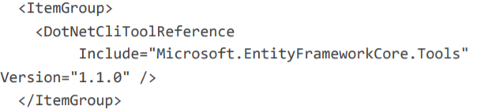

If you’re using Visual Studio Code, use this code snippet instead:

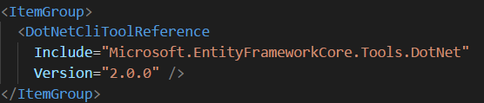

Because you’re using Visual Code Studio, you need to run command “dotnet restore”

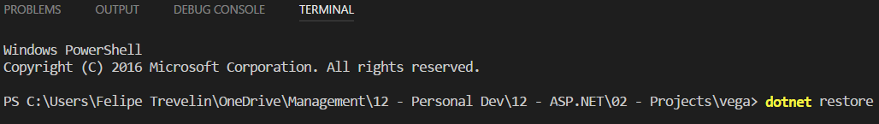

This command will look at the references in our **csproj** file and will get them from NuGet.

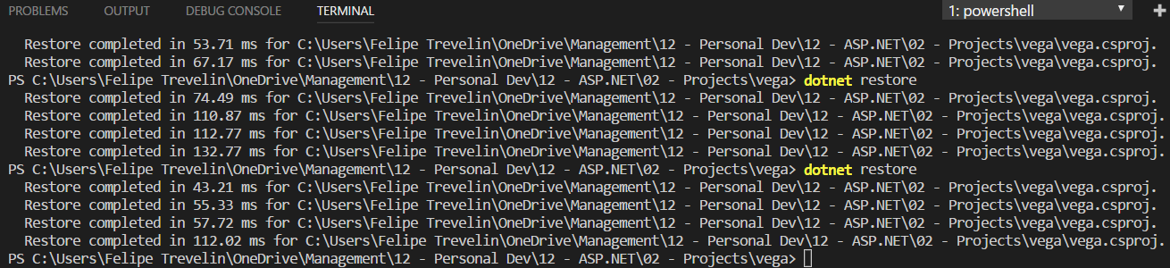

You should now have all the commands like “Update-Database”, “add migration” available for you to use. To test this, type “dotnet ef”:

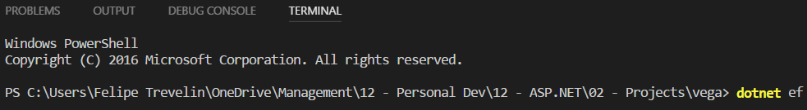

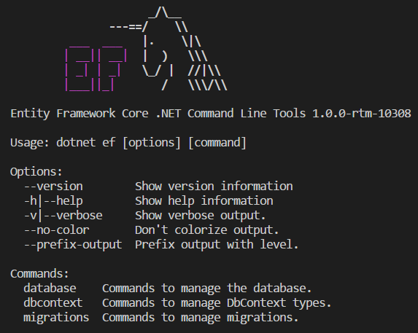

Let’s say you want to check which commands you have related to migrations, for example, type:



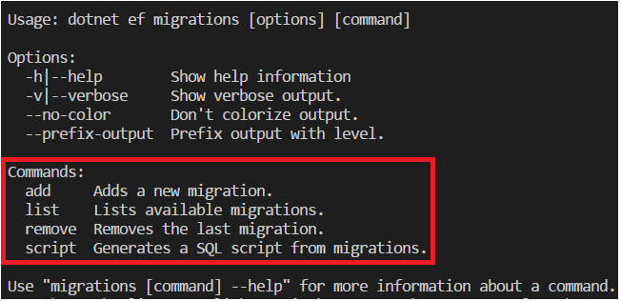

Also, you have to install this last

**DbContext**

The constructor of DbContexts is different in Entity Framework Core. Instead of receiving a string as the connection string name, they receive DbContextOptions:



First of all, let’s create a folder in the project path. In the terminal, type:



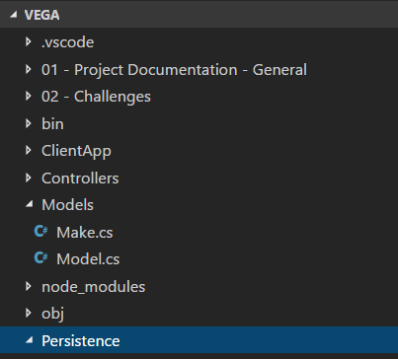

Within this folder, create a class “VegaDbContext” which derives from “DbContext”:

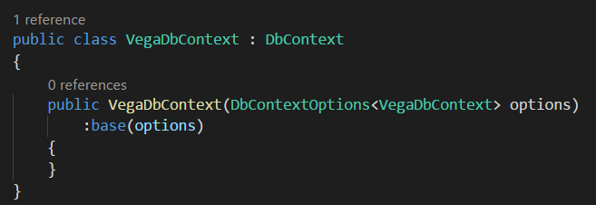

**DbContextOptions is new class in ASP.NET Core. It’s a generic class in which you should use the type of our context, which in our case is VegaDbContext. Then you should pass it (options) to our base class, which is DbContext (we’re inheriting from).**



Now, we need to register this DbContext as a service for Dependency Injection. So, later when you create a Controller, you’re going to pass this DbContext in the constructor or our Controller. An example below:

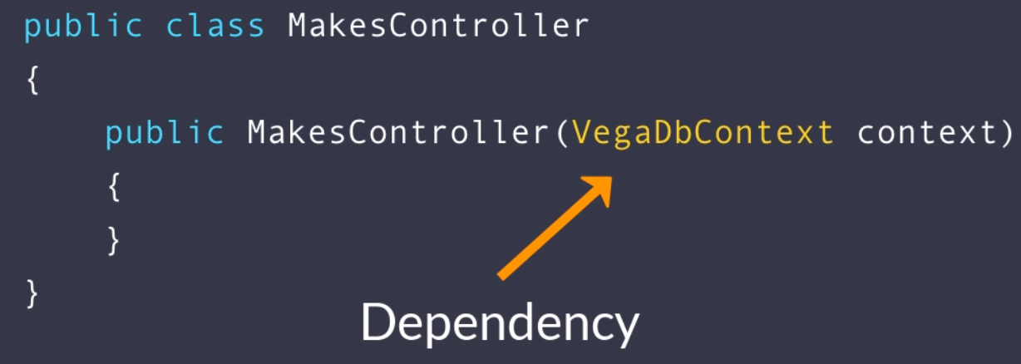

The Dependency Injection Framework inside ASP.NET Core would automatically create an instance of our DbContext and pass it to our controller. Later when we’re in unit tests, we can replace those dependencies with fake objects. It’s exactly the same reason we use dependency injection in Angular.

Now we need to configure this DbContext as a service for dependency injection. Access class “Startup.cs. This is where we register our dependencies. Enter the following:

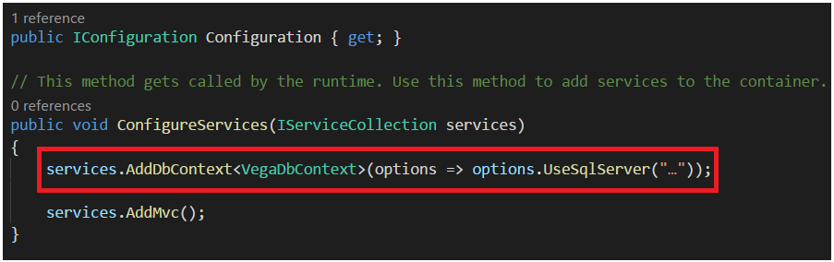

Let’s now open file “appsettings.json”. This is the new configuration file in ASP.NET Core replacing “Web.config”. We’re going to store all the configuration settings here. Just like the previous version of ASP.NET, here we’re going to have “ConnectionStrings” parameter:

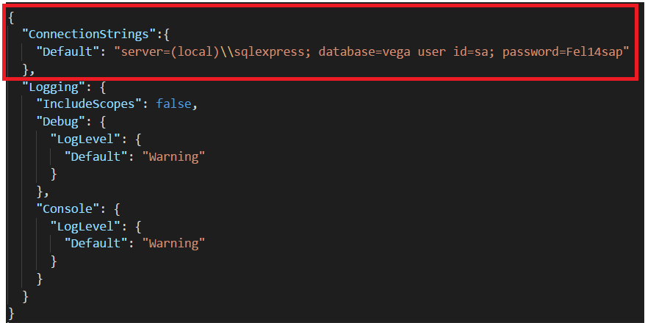

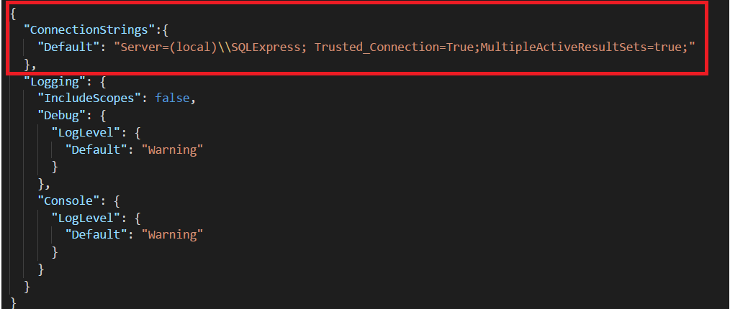

Now we need to read this in class “Startup.cs”:

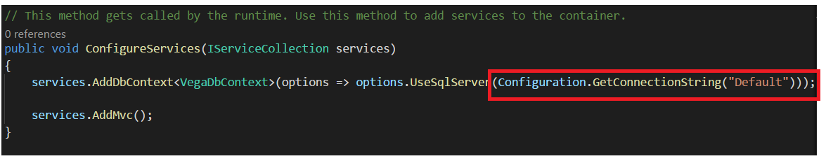

Just by calling a method GetConnectionString(), it will look for “ConnectionStrings” parameter in your Startup file. Then you pass the “Default” key in the key/value relationship. With this, system can figure out the value of this key, which you’ve set in file “Startup.cs”.

With this, your DbContext is ready and you’re now able to use CodeFirst Migration to create your database.

**AutoMapper**

This is a convention-based mapping tool that makes it incredible easy to map two different objects together. In this project, it will be used to map the Domain classes into our Resource classes and vice-versa. To install it, access your terminal and type:

If you’re using Visual Studio:



If you are using Visual Studio Code:



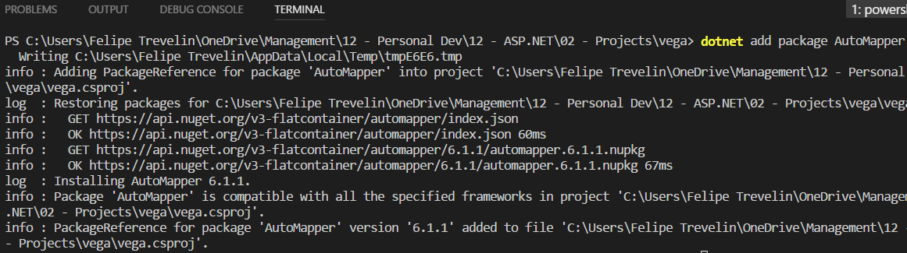

You also need to install Extensions for the Auto Mapper tool, as below:

If you are using Visual Studio Code, run:

dotnet add package AutoMapper.Extensions.Microsoft.DependencyInjection --version 1.2.0

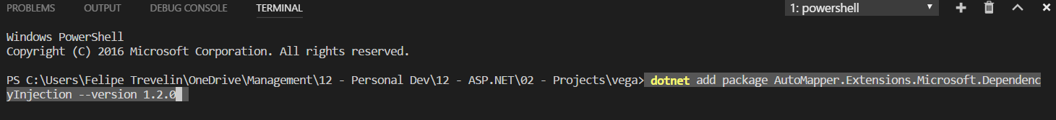

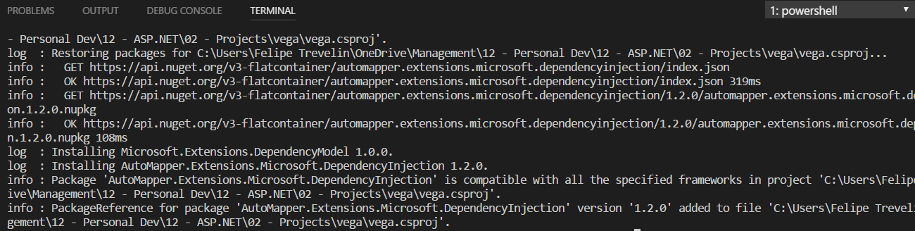

Now, run:



To finish, add Dependency Injection for **AutoMapper** in class “**Startup.cs**”:

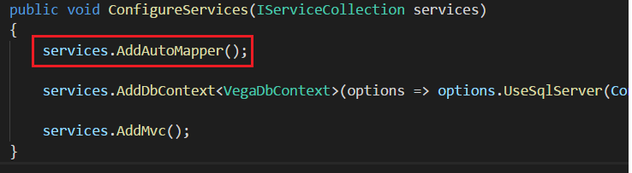

Now, create a class “MappingProfile” so that AutoMapper knows how to Automap the properties from one class to another. So, create a folder in your project:



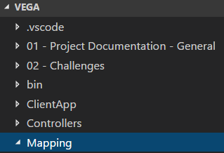

Now, create a new class “MappingProfile”:

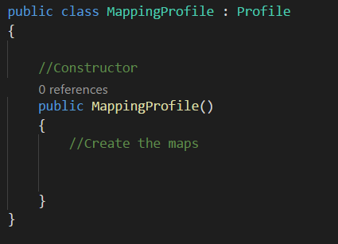

This class is ready for you to enter the Maps

**Angular**

We need to add a component Angular to our App project. First, we need to install the latest version of Angular CLI globally. Access the terminal and type:



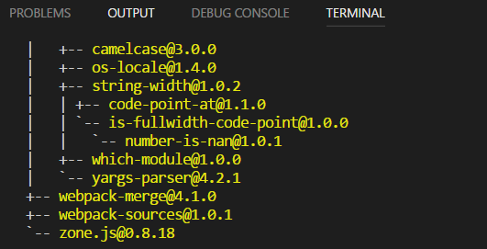

Now, you need to obtain a file called “**.angular-cli.json**”. In order to get that, you need to generate a new Angular Project using Angular CLI. To do that, access your desktop from your **Windows Command Prompt** and type:



After, type this to generate the template project:



Some small time after you see message , you press CTRL + C to stop it. If take a look at it, you will notice see the file there called “**.angular-cli.json**”:

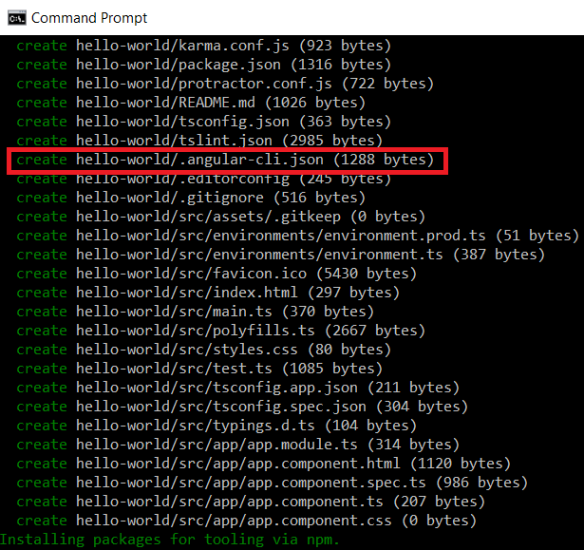

Now open the folder of your new project in your Desktop, the file and paste it on the folder of your project:

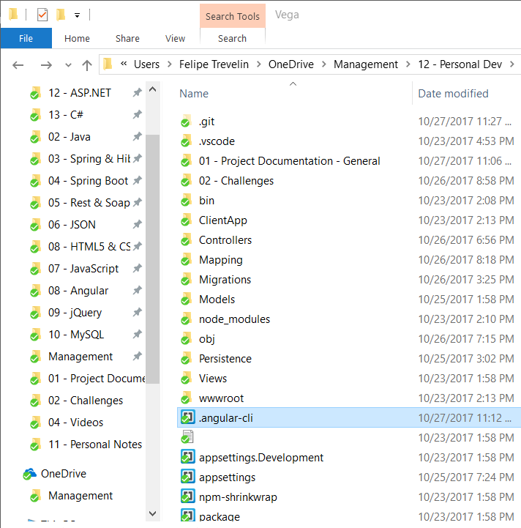

Now go to VS Code and find that you have a new file there for angular-cli:

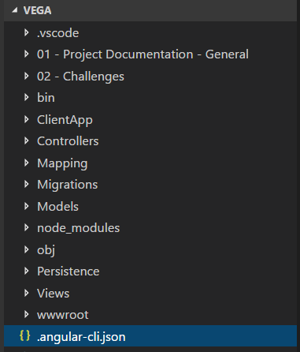

We need to make a small change in this file. Change the source folder to “ClientApp” because that’s where our Angular App resides.

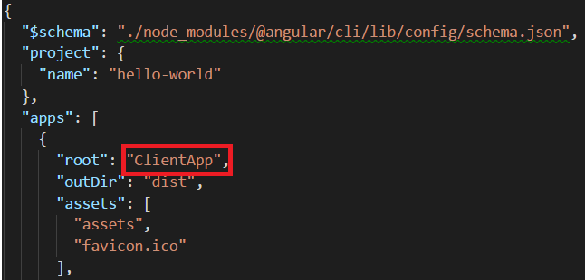

So, inside folder , we’ve got our Angular App.

Now go to your terminal in VS Code and install Angular CLI as a DEV dependency in your project. So, type the following command:



|  |
| --- |
| **3 – Installing Extensions** |

Open Visual Studio, right lick your project and choose:

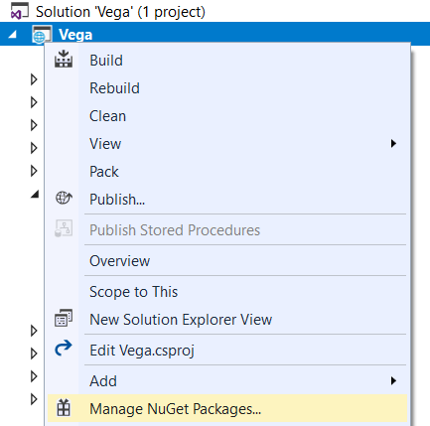

Add the following:

to begin your application development.

Before start coding, we need to install a few extensions. To do that, access the Command Palette, which is an interactive list whose purpose is to execute commands, by pressing **SHIFT + CTRL + P**. Then type “install ext” and choose option <Extensions: Install Extensions>:

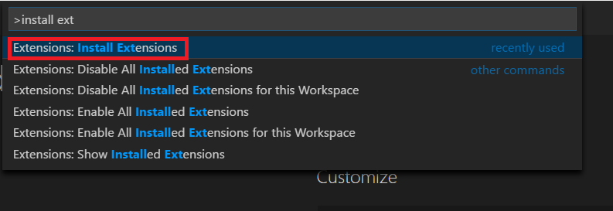

Here you can see the extensions you have installed:

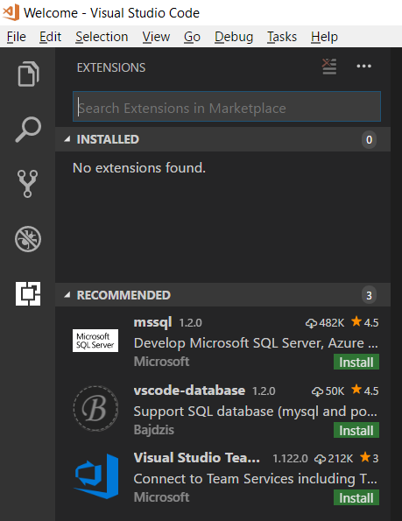

These are the extensions you need to install:

1 - **Angular v5 TypeScript Snippets** – With this, we can easily create an Angular component or a service by using a code snippet.

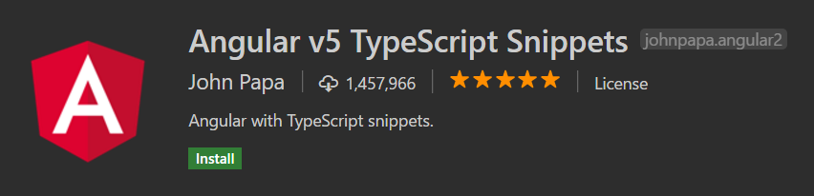

New press button .

After you have installed it, choose option  for this extension to take effect.

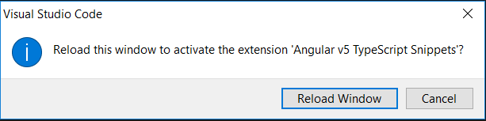

Choose <**Reload Window**>.

2 – **ASP.NET Helper** – This makes it easier to develop ASP.NET MVC applications.

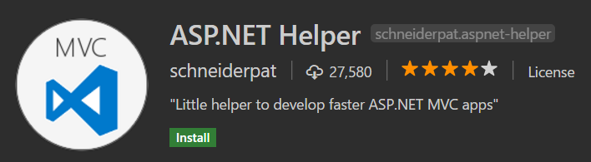

Repeat the same steps as item 1.

3 – **Auto Import** – This is extremely powerful when you’re writing typescript code. Without it, you have to constantly go on top of the file and add import statements. With this extension, you can automatically import the classes you have used in the current module

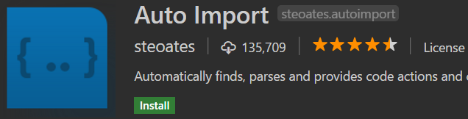

Repeat the same steps as item 1.

3 – **Beautify**  - This is used for formatting JavaScript and HTML code. That is not essential, but it’s a nice-to-have



Repeat the same steps as item 1.

4 – **C#**  - C# programming language.

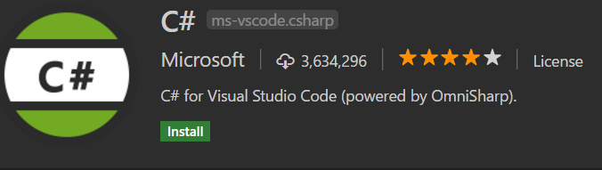

Repeat the same steps as item 1.

5 – **C# Extensions** – Extensions for the C# programming language. It will give you syntax highlighting, code completion, so on.

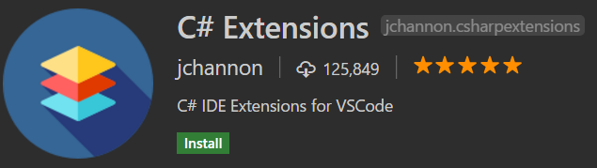

Repeat the same steps as item 1.

6 – **MSSQL** – With this, you can connect to a SQL Server Database, look at your tables, write queries and so on.

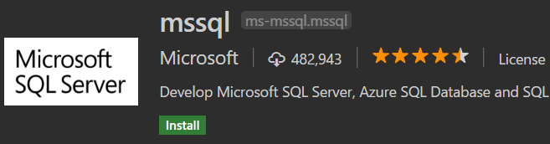

Repeat the same steps as item 1.

7 – **REST Client** – With this, you can call RESTful endpoints.

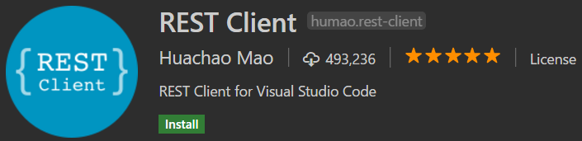

Repeat the same steps as item 1.

Finally, we need to install a couple of Node packages. **Noje.js** is a platform built on Chrome’s JavaScript runtime for easily building fast and scalable network applications.

1 – **Yeoman**  – In Visual Studio IDE, whenever you create a new project, you automatically get a bunch of folders and files that come from a template. VS Code doesn’t have this feature.SO, we need to use Yeoman to generate a template for our new project. To install it, open command prompt and type:

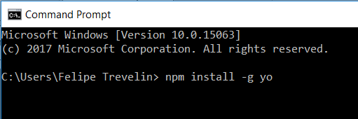

Installed as below:

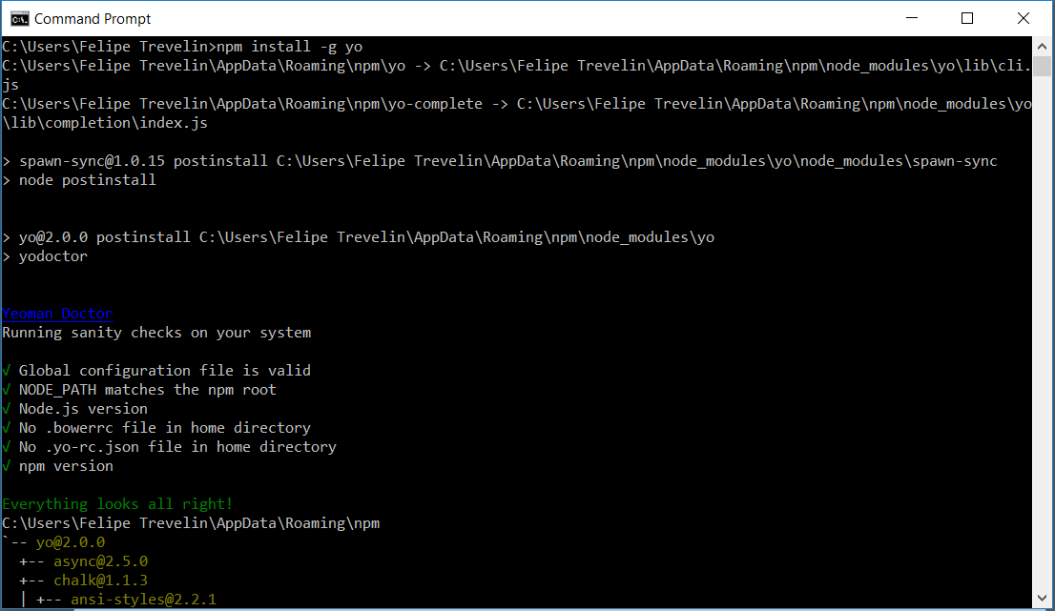

|  |
| --- |
| **4 – Create the Project** |

To create your project, open command prompt and execute the following steps.

1 – Create a new folder through command “**mkdir vega**”:

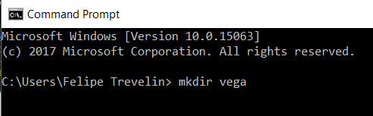

Access this new folder through command “**cd vega**”:

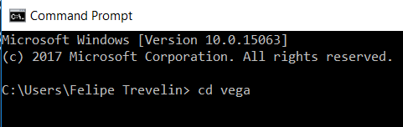

Now, create the project through command “dotnet new angular”.

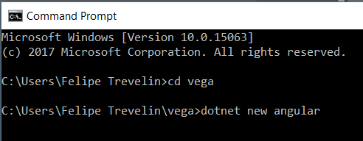

Now, type “npm install”:

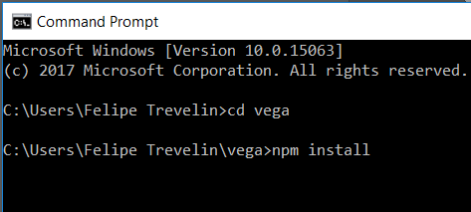

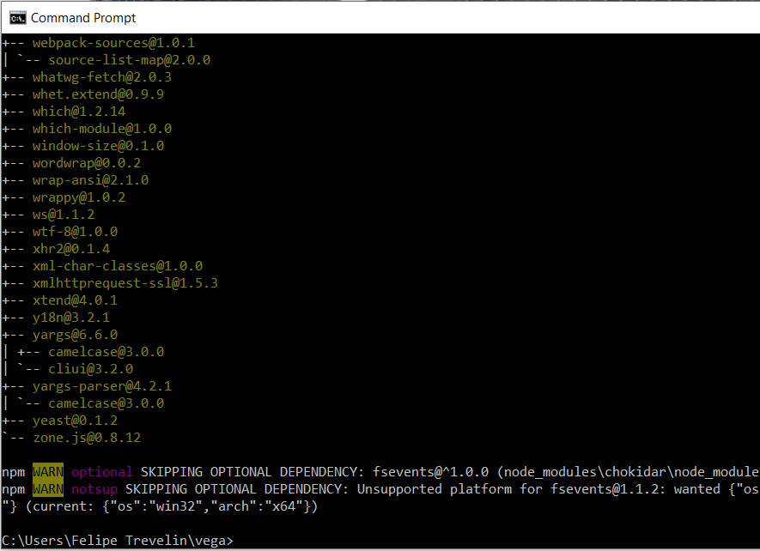

Now run command “dotnet run”:

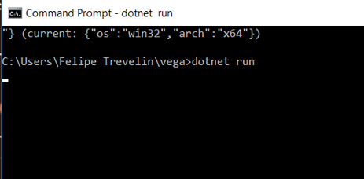

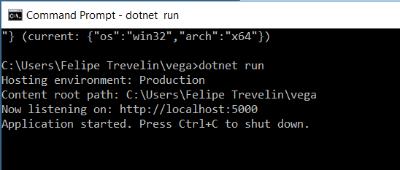

You are now running your program. To check that, access URL <http://localhost:5000>

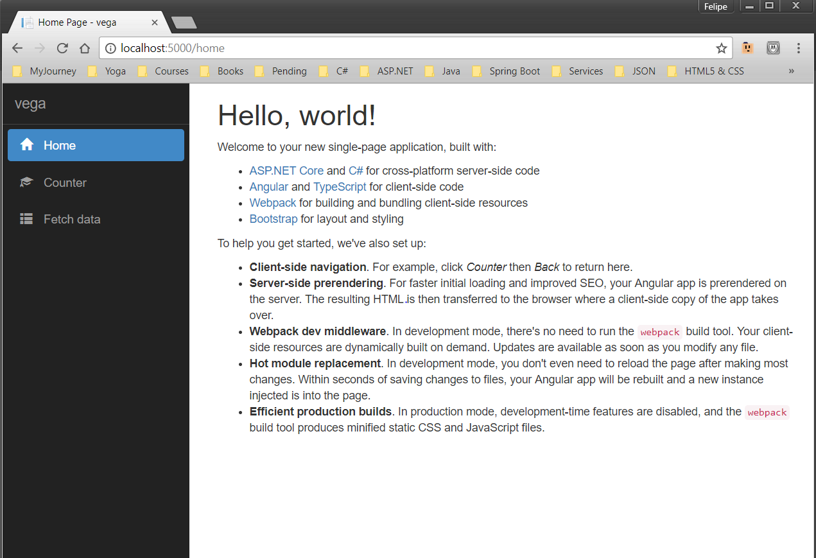

This is tour project template.

To stop your Application from running, press CTRL + C:

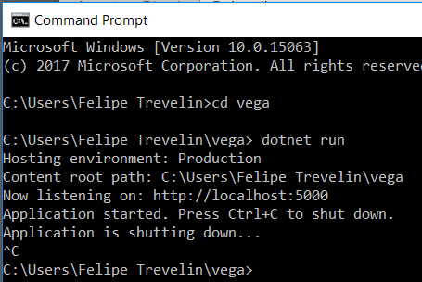

There’s also another way to open this project.

Open Command Prompt and write “code .”:

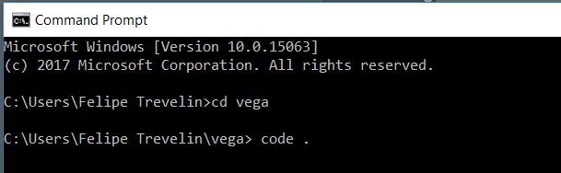

It will open your project in VS Code:

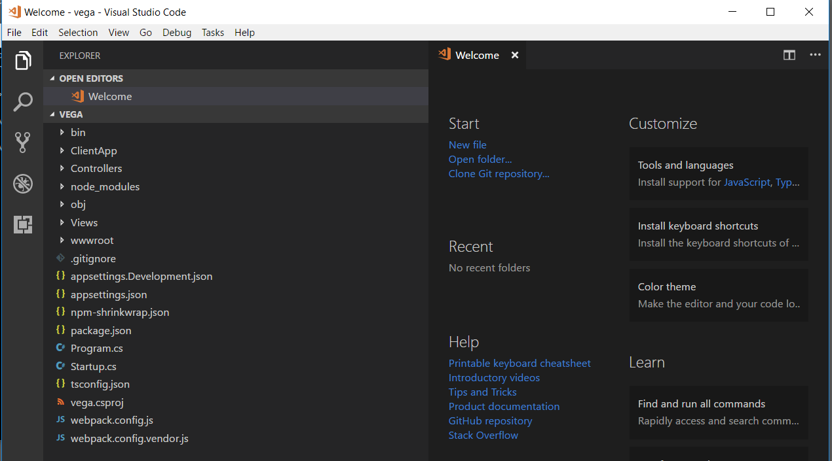

Now press CTRL + key **` (one before number 1 in your keyboard):**

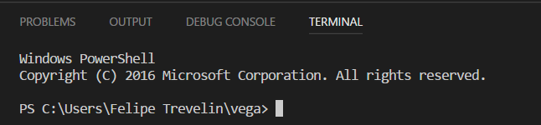

Now, type “dotnet run” in this command prompt:

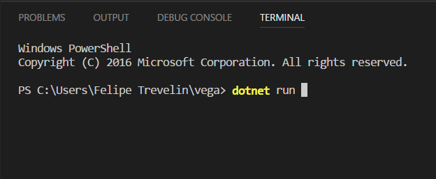

If you try to access URL <http://localhost:5000>

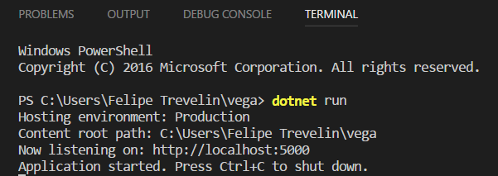

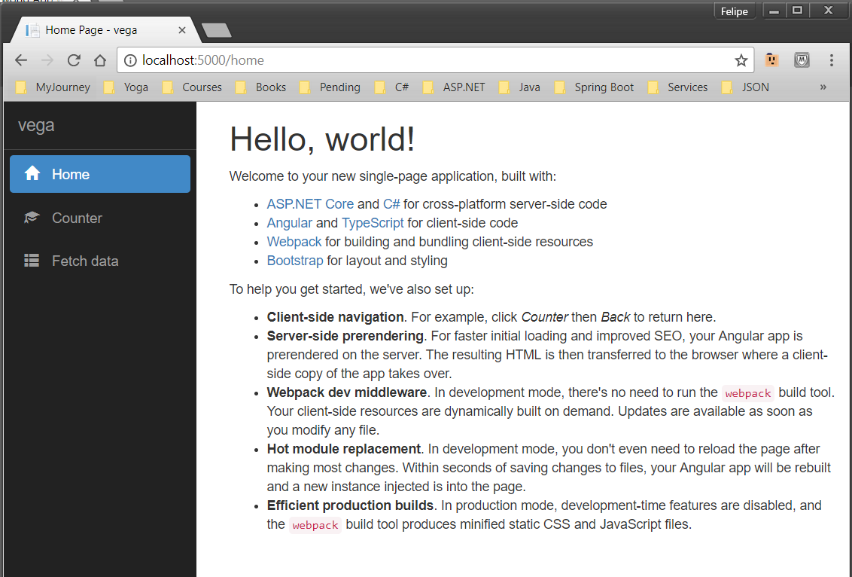

|  |
| --- |
| **5 – ASP.NET Core Characteristics** |

**Server**

Like in Console applications, ASP.NET Core we have a class called “**Program**” with a method called Main, which is the entry point to our application. ASP.NET Core applications are similar to Console applications in that regard.

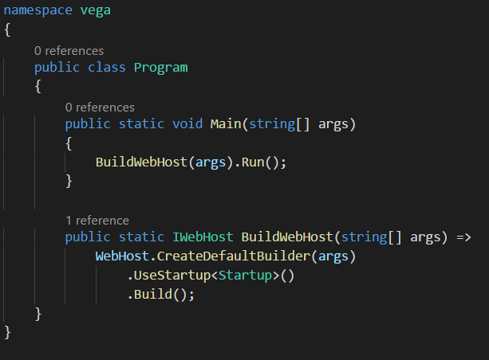

Over these lines, we’re configuring and running a web server to host our application.

ASP.NET Core comes with two in-process HTTP Server implementation:



Kestrel, which is a new web server, can run on Mac, Windows, Linux. it doesn’t have all the features of IIS, or Apache. It’s not very secure, but it’s good enough to be used in an internal network. So, if you’re building an application for internal use, you can use Kestrel. But, for a public-facing website, you need to put Kestrel behind IIS on Windows, or Apache on Linux.

WebListener, on the other hand, is only for Windows.

**Request Processing Pipeline**

When a request comes in as web server, imagine it goes through a pipeline:



In this pipeline, there are multiple components which we call Middleware. Each Middleware is like a function. It looks at the incoming requests and if interested in that request, it will do something with it. Otherwise, it just skips. The previous version of ASP.NET, in ASP.NET MVC 5, our request processing pipeline was fairly heavy weight. And we didn’t have control or reconfiguring these Middleware. In ASP.NET Core, we can customize this request processing pipeline and add only the Middleware that we need. This way, we can improve the performance of our application, because CPU Resources are not wasted for Middleware that we don’t need.

Let’s take a look at a few examples:

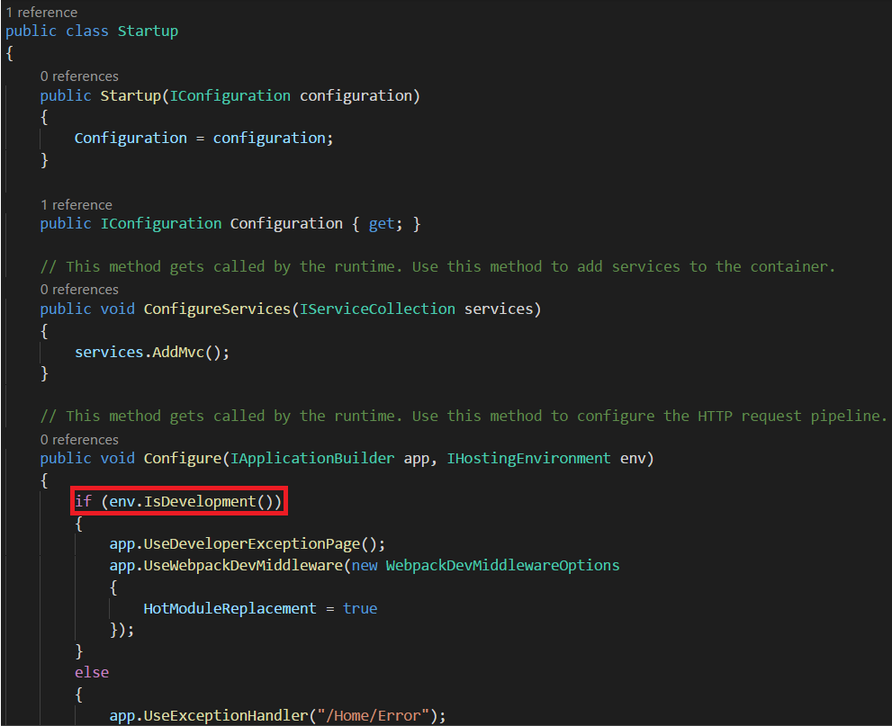

Here, if Environment is equal do Development, we add a couple of Middleware:

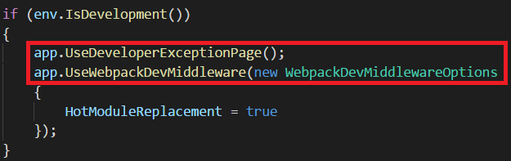

One is “**DeveloperExceptionPage**” which renders an exception with all its details and the other is “**WebPackDevMiddleware**” which will automatically compile JavaScript, CSS and typescript code if we make any changes to that and push the changes to the browser, so we don’t even need to reload the page. This is called “**HotModuleReplacement**”. These two Middlewares are only used in the development environment. We don’t want that in production.

Here’s another Middleware:

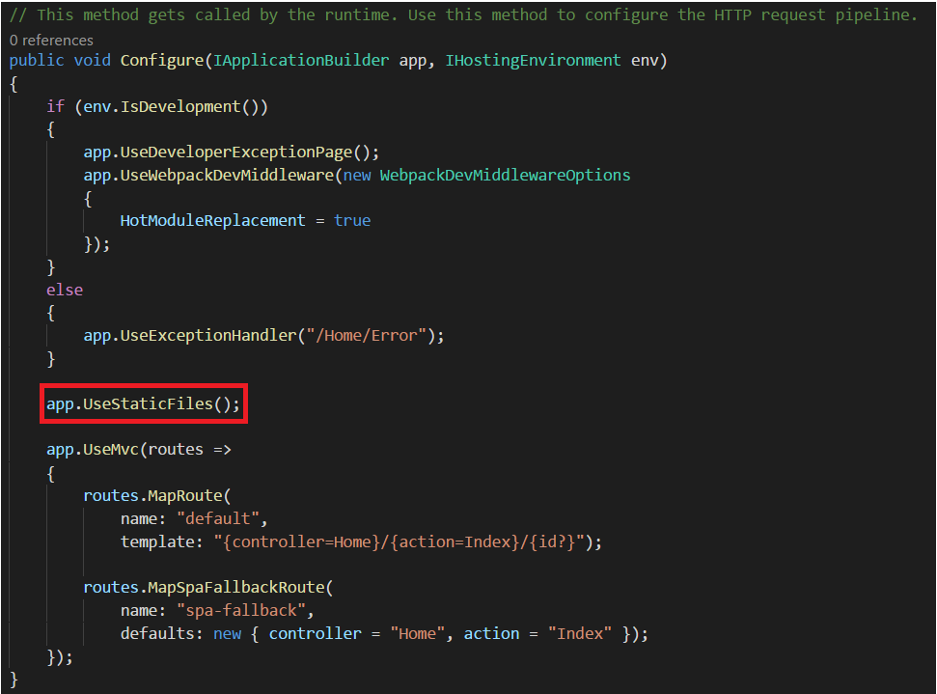

With this, we’ll be able to search serve static files like images, stylesheets and so on. If you comment out line, we won’t be able to serve any images or stylesheets from our application. And this is a Middleware that every ASP.NET needs.

Finally, the last Middleware is MVC:

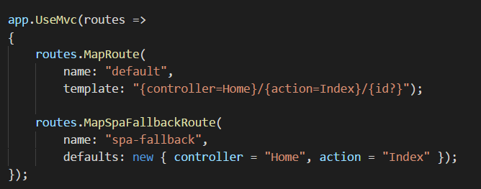

MVC is nothing but a Middleware. When a request comes in, this Middleware looks at the request and based on our routes, it will forward it to an Action and a Controller.

In order to test **HotModuleReplacement**, run your application, access “Fetch data” and click console:



You will find this message called [HMR] which stands for **HotModuleReplacement**. If your machine is configured as the Staging or Production Environment, you’re not going to see this message, because this Middleware is set exclusively to Development.

Now, if you access the HTML file that holds this view and make the following changes:

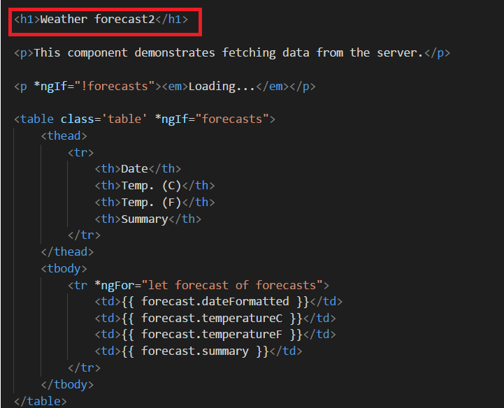

If you save, find that your webpage is updated without the need to reload it:

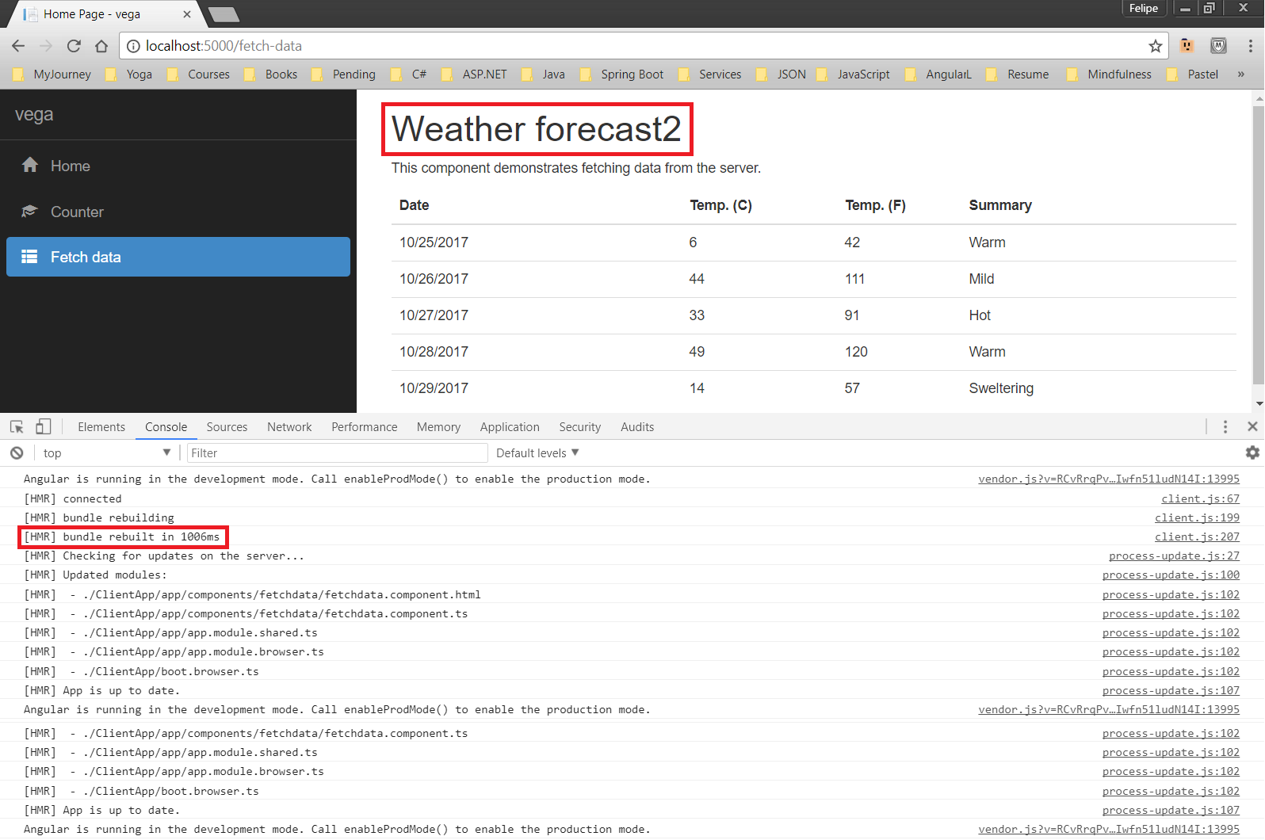

Also, in the console tab you can see that WebPack rebuilt our bundle. Below that, you can see the updated modules, that is, the modules that were affected by the change you’ve made. So, with WebPackDevMiddleware, anytime you modify you **client-side code**, assuming you are in the development environment, changes are automatically pushed to the browser.

When it comes to server-side code, any changes made to it are not recompiled automatically. For example, suppose you’ve run your app and have the page open:



Now if you access HomeController and enter an exception in the “**Index**” action:

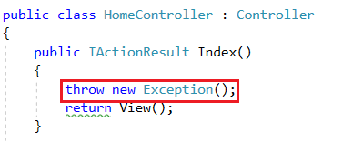

If you save, open the same page you had and press F5 to reload, you get this:



Same thing. You don’t see the changes because our server-side code is not recompiled. So, we need to get back to terminal, stop this process and run it again. Such a tedious process. Let’s see a better way to do it.

Access the URL <https://github.com/aspnet/DotNetTools> and click the following link:

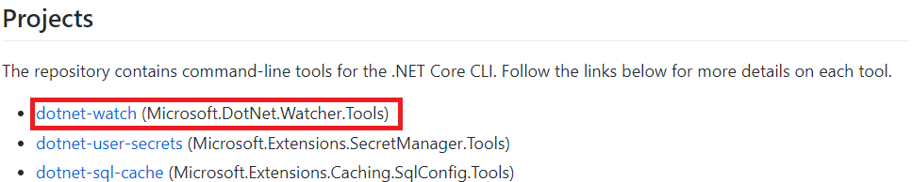

On the **dotnet-watch** page, you can see this code that you need to copy:

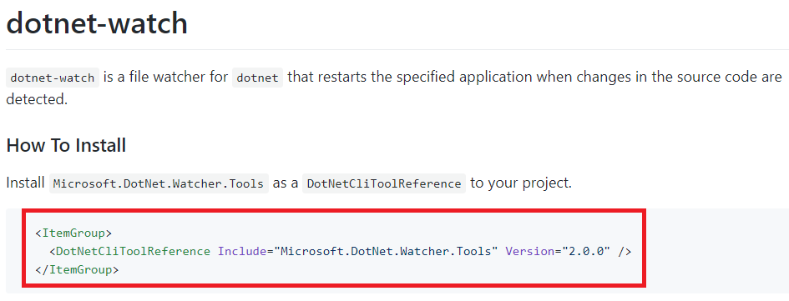

Now, back in VS Code, open file “**vega.csproj**” and enter past it there just below the project element: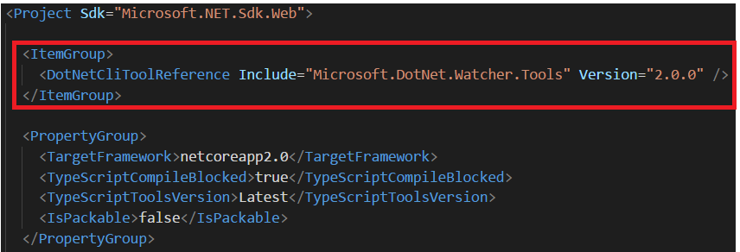

Now back to our terminal you need to run command “dotnet restore”



This command will look at the references in our **csproj** file and will get them from NuGet.

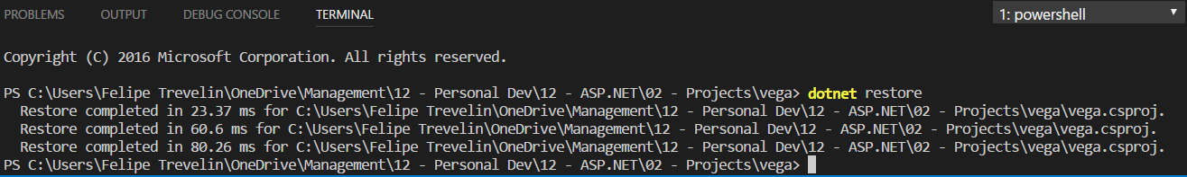

Now, to have that feature available when you run your app, instead of “**dotnet run**” type “**dotnet watch run**”:

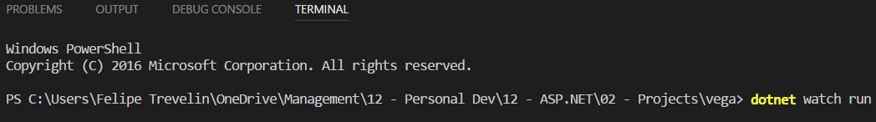

This will set up a listener. Anytime you modify your C-Sharp code, it will automatically recompile your code on the fly.

|  |
| --- |
| **6 – Source Control** |

In this project, we’re using Git repository. To add our project to Git Repository, click the following:

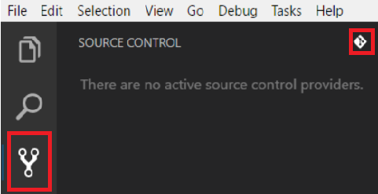

See the changes:

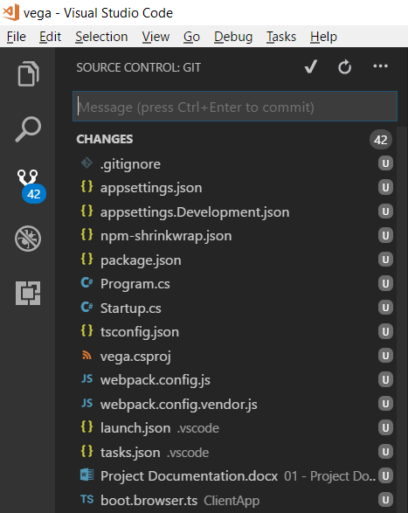

With this, if you access your project’s folder, you should see a file named “**.git**”:

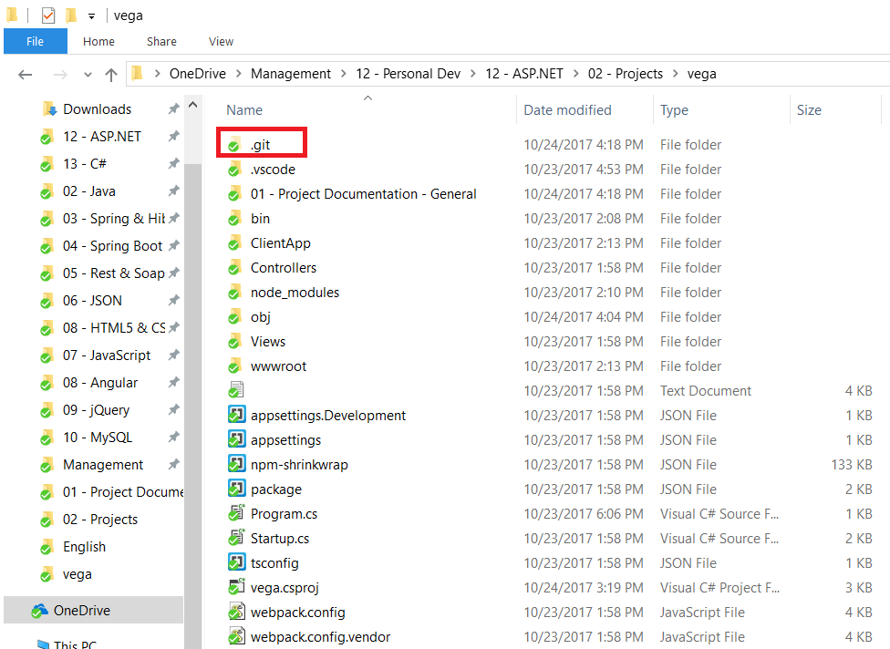

Now go back to VS Code and type:

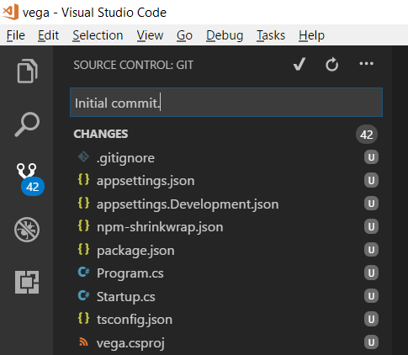

Press  to commit.

|  |
| --- |
| **7 – Approach to Build this Project** |

**General Approach**

Every software application starts with a Requirements document. This requirements document can be one page, or 500 pages. Irrespective of how big this requirements document is, your first task is to extract the use cases in this application. ***Use cases are the actions that the user can perform***. Here’s an example:

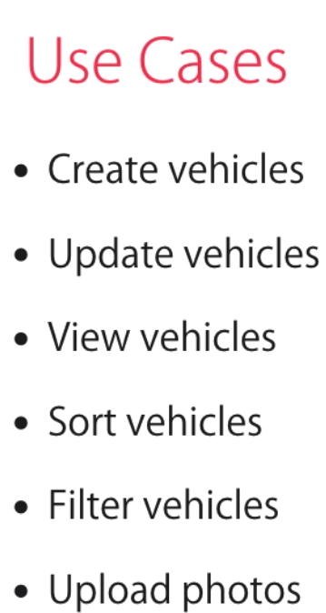

Once you have these use cases, you need to find their dependency. So, we can start anywhere in the list, say “Filter vehicles”:

In order for us to build this feature, first we need a list of vehicles and in order to build this vehicle’s list, first we should be able to create vehicles and store them in the Database. So, here’s the order to implement these use cases:

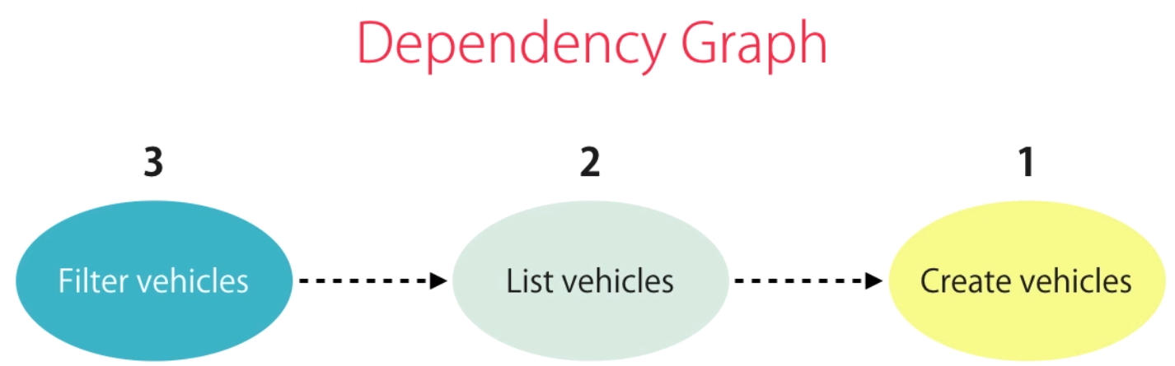

You’re going to start with “Creating a Vehicle”, once we deliver that function then we move on to the second step, which is “Listing the Vehicles” and finally the third task, which is “Filtering Vehicles”.

What is critical for you to understand here is that when you’re building the list of vehicles, you should not worry about all the other fancy features, like filtering, sorting, pagination and so on. This is a mistake that a lot of junior developers make. They try to do so many things at once and that’s why they get lost in detail and deliver poor quality software. So, focus entirely on building a list of vehicles. And that list doesn’t have to be fancy. Render the vehicles in a very simple list. Once it’s working, then you can make it look better applying some styles, adding icons and so on. Once you deliver that feature, then you can move one to the third step.

So, in our current dependency graph, we’re going to start with “Create vehicles” use case. For this use case, sketch a simple form:

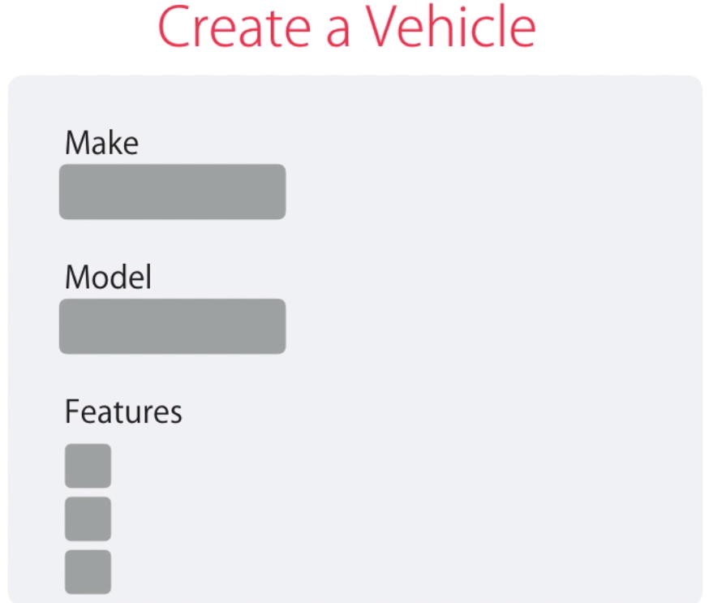In this form, we need a dropdown list for the vehicle Make. Once the user selects a value from this dropdown list, then the Model dropdown list should be repopulated, because models are based on the makes. What’s important here is that the items in these two dropdown lists come from the server. So, somewhere in our application we need to register in the Database all the standard Makes and Models. Similarly, we need a list of features that are available in this vehicle. So, we need a checkbox list and the items in this list are rendered dynamically. Again, we need to store a list of standard features in our Database and this data should come from the server.

Back to our Dependency graph, you want to build this feature “Create Vehicle”. In order to build this, first we need an Angular Form. This form needs its data from the server. So, in order to build this form, first we need an API with one or more API Endpoints, so we can get the data to populate this form. Next, in order to build this API, we need a database to store our data. But how do we create our database? You’re going to use Entity Framework CodeFirst Migrations. So, the first thing we create is our Domain Model and then use CodeFirst migrations to generate or update our database.

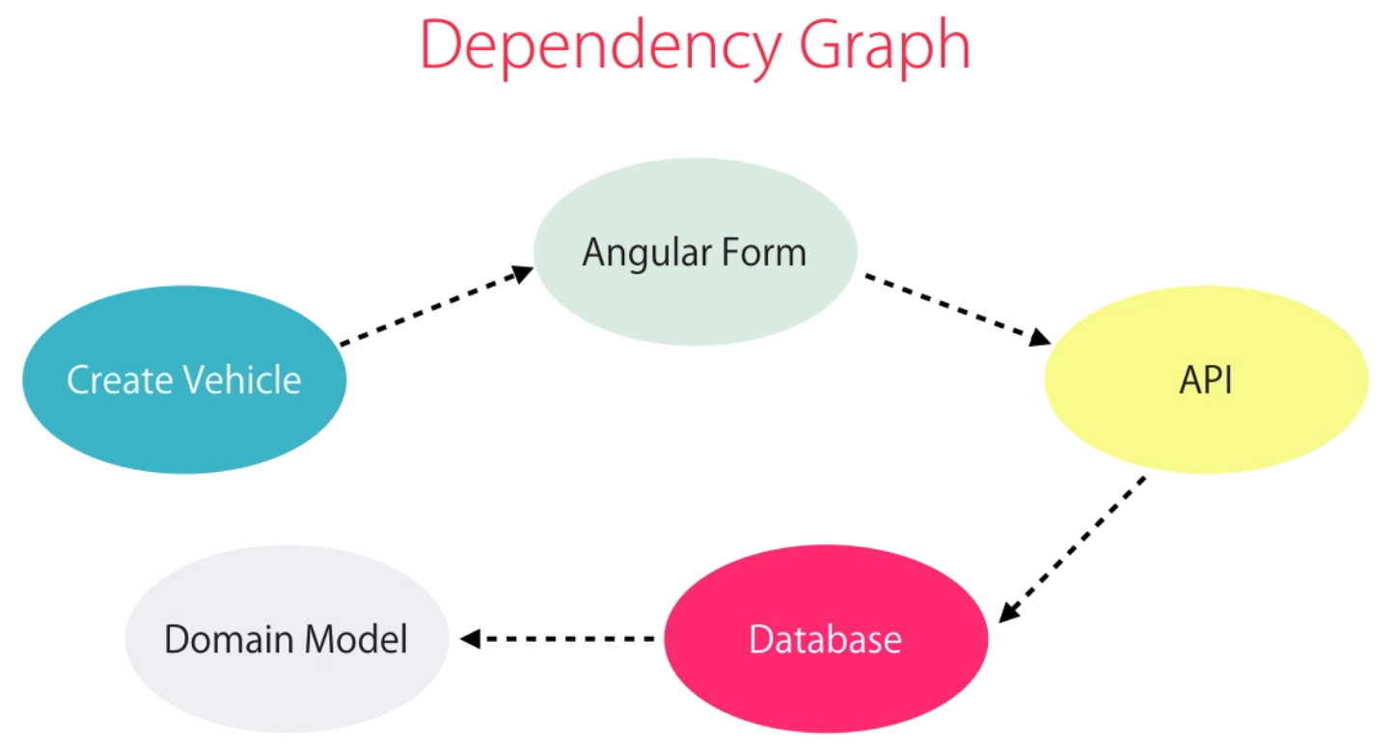

This is a good approach to follow in order to establish the activities which should be done.

A very common mistake junior or intermediate level developers make. They start with all these fancy UML Diagrams, with tens and hundreds of classes and then try to build them all in one go. That’s a recipe for failure. Don’t do that. That’s why in here, we’ll start by building a basic simple piece of functionality. We’ll build our Domain Model with “Make” and “Model” classes and build an API to return Makes and Models.

|  |
| --- |
| **8 – Architecture** |

The Domain classes that will be created in our project, like Make, Model, are internals of our application. We refer to these as Implementation Detail. We don’t want to expose the implementation details outside our application boundary. Because the implementation can change, and this would break any clients dependent upon our implementation.

Instead we need a separate layer of classes and our Application Boundary and refer to these classes as the **Public Contract** or **Public Interfaces** of our application.

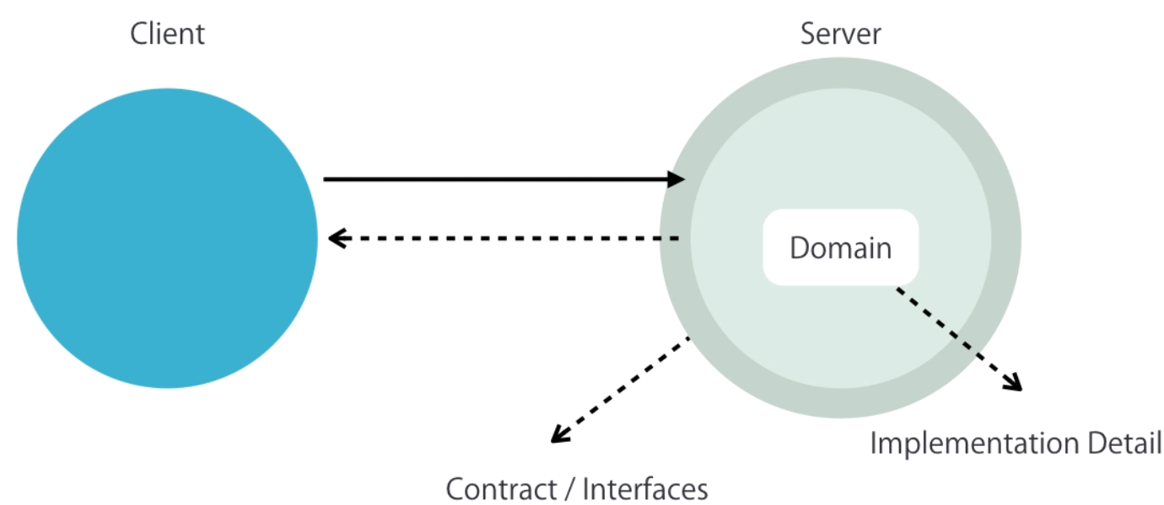

In here, we’re not talking about C# Interfaces. We’re talking about interfaces as a concept. Let’s see a metaphor to understand this concept:

Think of a DVD Player. It has a logic board, with a bunch of transistors that we don’t see. These are the Implementation Detail. What we see are the buttons on the front. And this is what we call the Public Contract or the Public Interface of a DVD Player.



The Manufacturer may change the internal implementation, and this will not impact us as long as these front buttons stay there. We have the exact dame concept in Software. Back to our project, we don’t want to expose our Domain classes outside our application boundary. We don’t want to Serialize them and send them over the wire to the client. Instead, we need a different set of classes that look similar to our domain classes, but they can change and evolve independently. These classes will be at our Application Boundary and our Controllers are going to take them as the Input and serialize them as their Output.

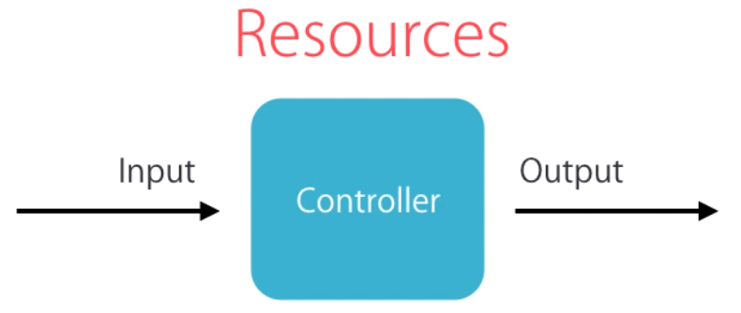

In the REST terminology, we refer to the objects that a client requests from the server as **Resources**.

So, first of all, you should create a folder under “**Controllers**” folder:

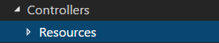

Then, for each Model class that you would need to Serialize, create a class here with name <ClassName + Resource>, for example <**MakeResource**> or <**ModelResource**>. Real examples of these classes are:

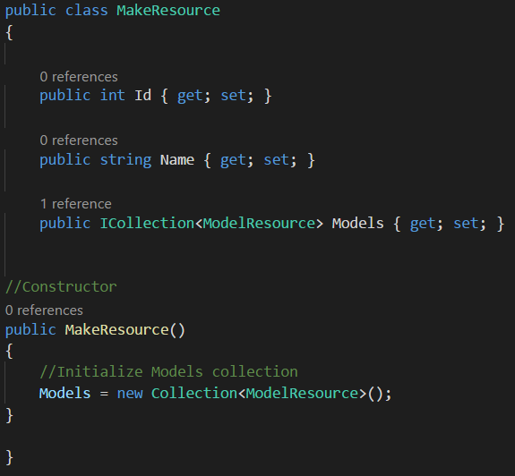

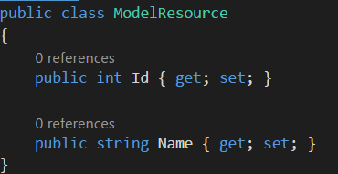

**Note that for the Model Resource, we removed some unnecessary fields that would cause a loop when serializing.**

To make that work, it’s also necessary to map the Domain classes into our Resource classes. For this we’re going to use Auto Mapper. For AutoMapper settings, refer to the Set Up Environment section.

To use the AutoMapper, access your MakesController and do these changes:

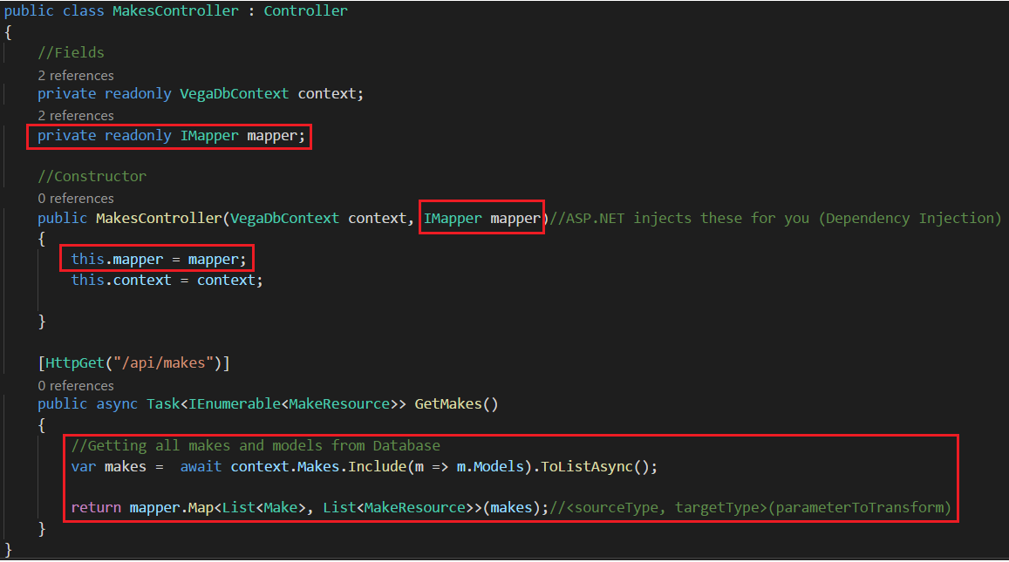

Also, enter the Mapping from Make to MakeRerources :

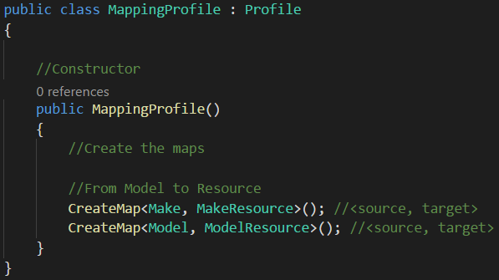

If you test your API now:

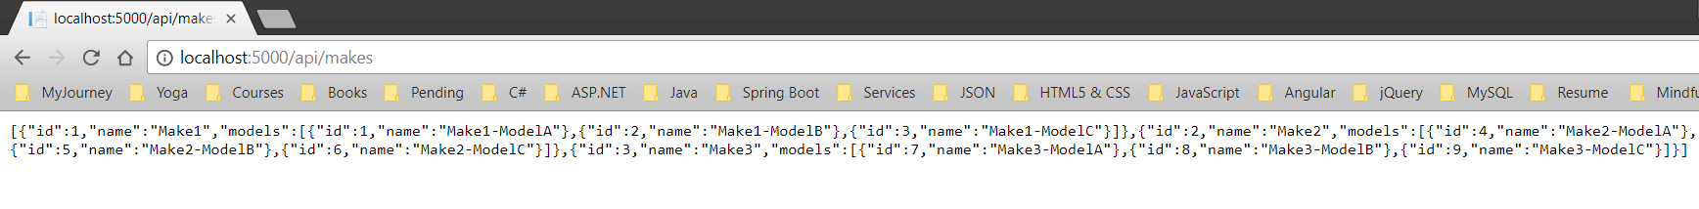

|  |
| --- |
| **9 – Domain Model** |

Let’s start by creating the Domain Model.

1 – Crete a new Folder for your Models.

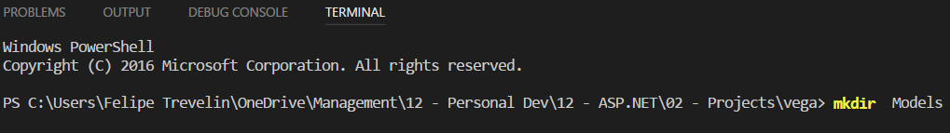

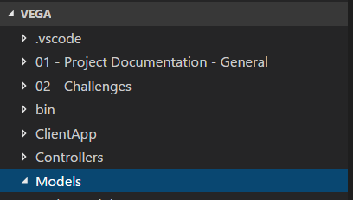

2 – Create the classes for your Models

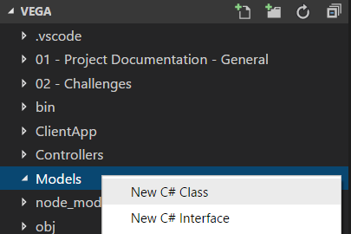

**Make class:**

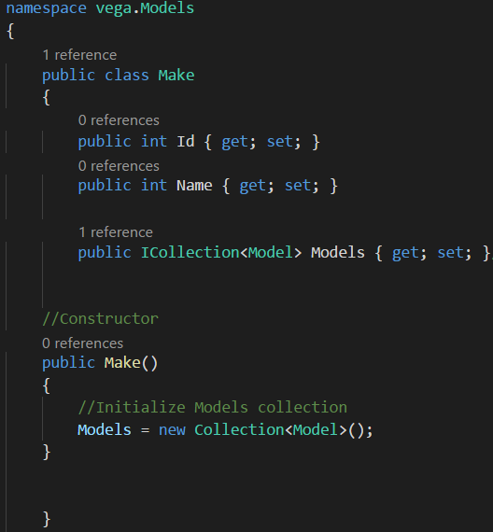

**As a best practice, whenever you have a collection property in the class, you should initialize it in the constructor of that class. Because we don’t want somewhere else in the code to create a new collection object. Also, if someone instantiate this class, this object would come already as non-null. Initialization of this property is the responsibility of this class.**



**Instead of ICollection, you could use IList. List gives you the ability to access items in a collection by their index.**

**Model class:**

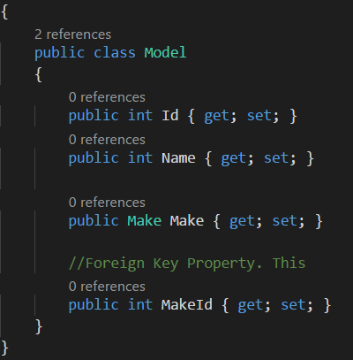

**To associate two tables with a foreign key, use the identifier of the other table as a property in your table, like above. You just have to enter a property with the name of the Class + the name of the Property. In the case above, you used “MakeId” (Make = class, Id = Property). Entity framework will also notice that the Make object and the MakeId are referring to the same thing:**



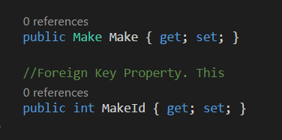

**So, when you use CodeFirst migrations, it’s not going to create an extra column for you. Also, the type of this foreign key MUST be the same as the original key in the foreign table.**

|  |
| --- |
| **10 – Migrations** |

One our Domain Model is ready, we can use CodeFirst Migration to create the database with the tables according to our Domain Model.

If you’re using Visual Studio, use this command to create your Migration in Package Manager Console:



If you’re using Visual Studio Code, access your terminal and write:



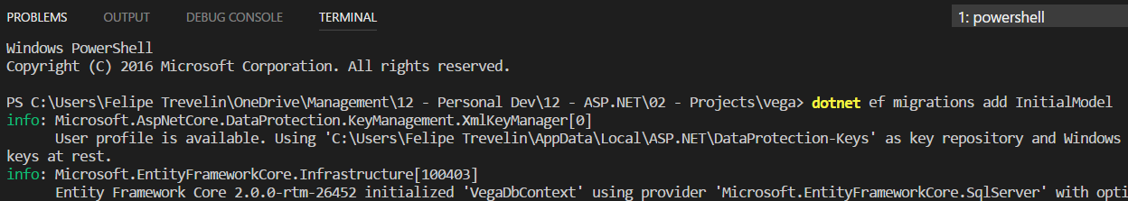

If you check your project, you will find that a new folder “Migrations” have been created:

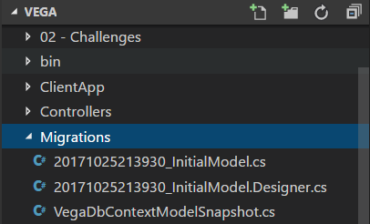

If you access the first file “InitialModel.cs” you will notice it is empty:

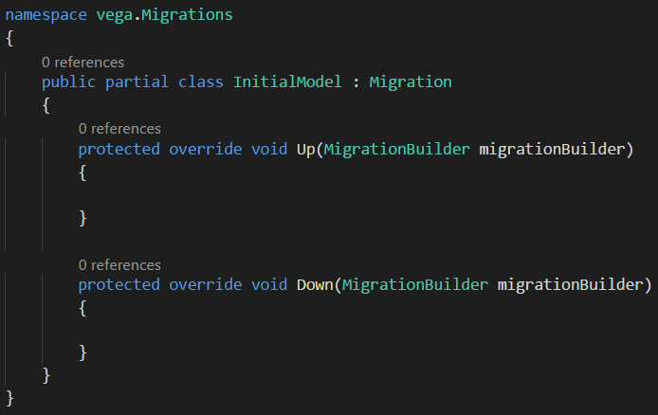

This is an issue you’ll encounter quite frequently when using CodeFirst migrations. The reason for this is because Entity Framework looks at our DbContext to determine what our Domain Model looks like.

If you check your DbContext class, you won’t find any DbSets. So, from Entity Framework’s point of view, there is nothing in our Domain Model. Even though we created the classes “Make” and “Model”, Entity Framework does not see them as part of our Domain Model. So, you need to add DbSets to your DbContext:

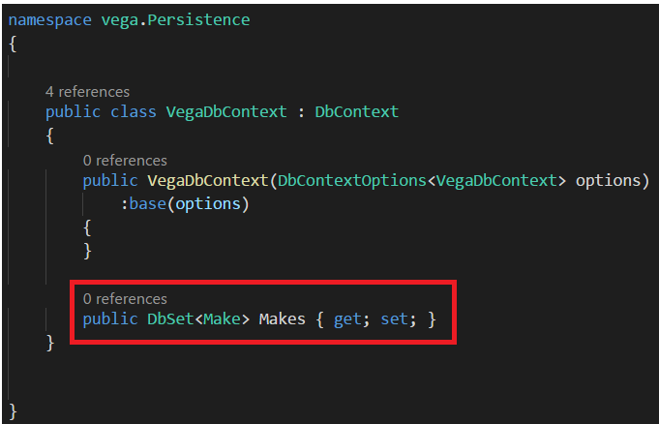

**Note that you don’t need to add ad DbSet for the “Model” model here. If you take a look at the Make class you will find that in there, you already have a Property that refers to a collection of Models, as below:**



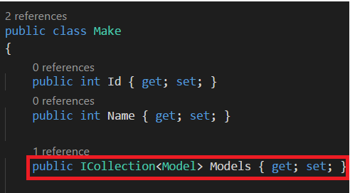

**This is because Entity framework starts by this “Make” class. And inside this class we have a relationship to the Model class. This way, Entity Framework can implicitly discover this class. So, we don’t need to explicitly add a DbSet of “Model” in the DbContext. You would need that, only if you needed to query them directly.**

Now, we need to recreate our migration. Let’s first remove the first migration:

If you’re using Visual Studio, write in the Package Manager Console:

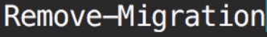

If you’re using Visual Studio Code, write in the terminal:



This removes the very last migration that was not applied to the Database.

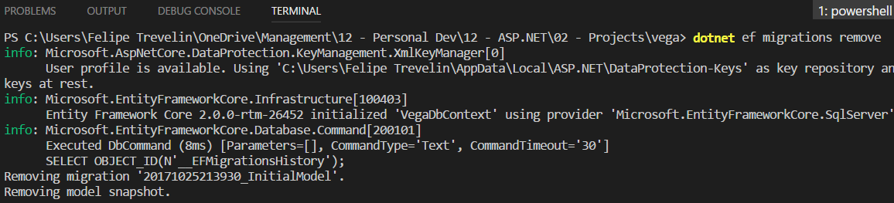

**Find that “Migrations” folder should be empty.**



Now you can recreate your Migration again:



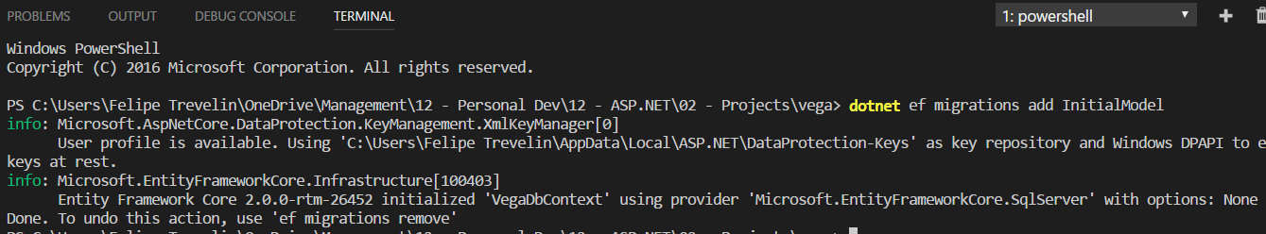

If you check your Migration Folder again, you will find:

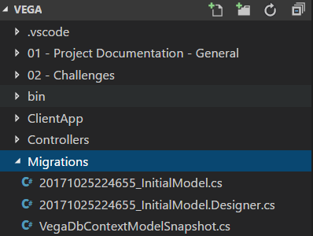

**The files are all back there.**

Access the first file “InitialModel.cs” again and check your Domain Models are all in there with two tables being created “Makes” and Model:

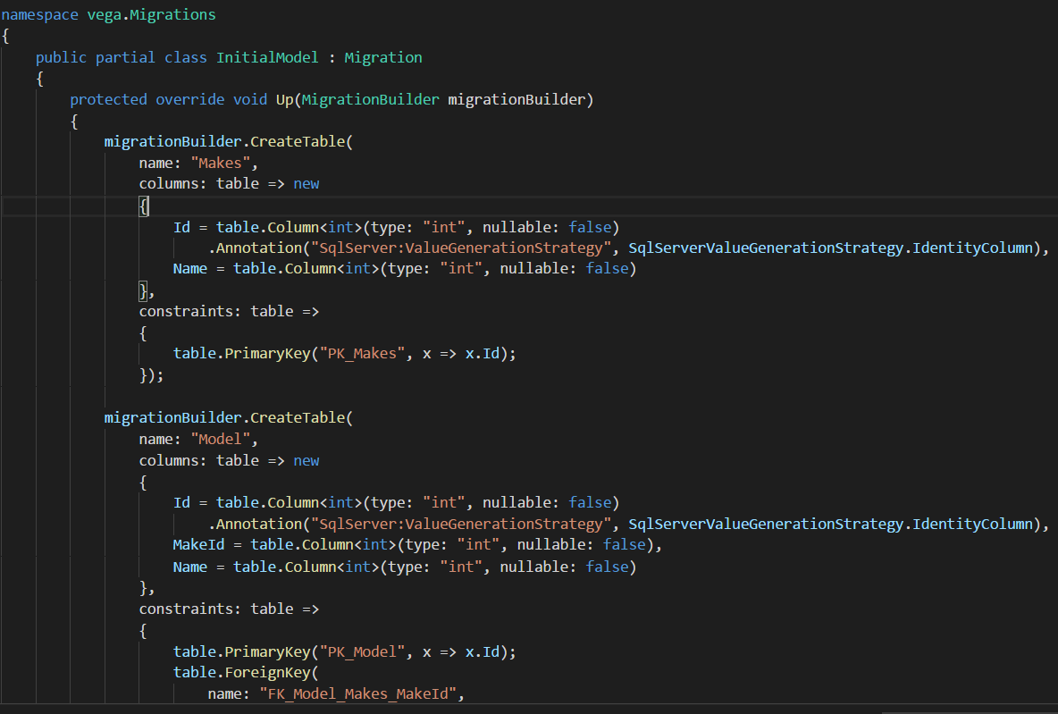

Finally, we need to apply this migration to our database.

In Visual Studio, you can run:

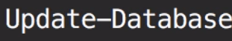

In Visual Studio Code you run:



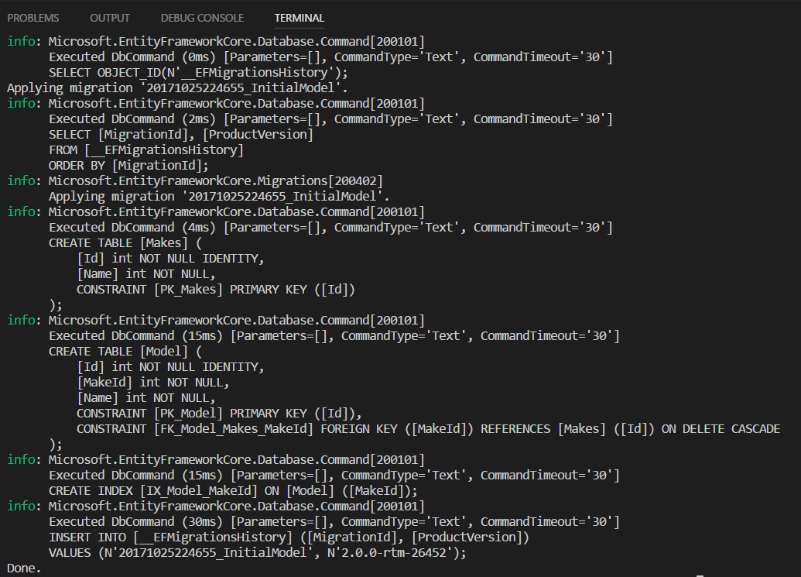

You should now see the table in the SQL Server:

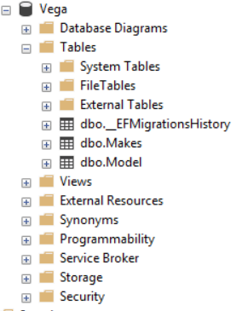

However, there’s an issue with our table. If you take a look at their columns, you will notice:

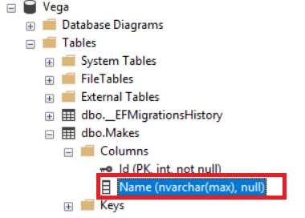

If you look at the data type of Column “Name”, you will notice it is **nvarchar** of **max**. When the type of a property is a string, Entity Framework by convention, **nvarchar** of **max** for that. Also, you can see that this column is nullable and the reason for that is because strings in C# are nullable. So, we want to make this column required and limit the number of characters to 255.

The second issue we have with this table s the name of the Model table. It’s not plural.

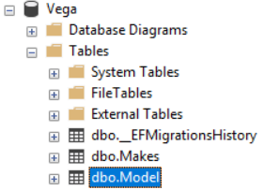

The reason for that is because Entity Framework Core is still immature. In this particular case, I have no idea why it didn’t realize it should use “Models” instead of “Model”. In order to correct that, we need to downgrade the Database to the previous version of it.

This is how you downgrade your database to a previous version:



Wait. Isn’t it the first version of our database? Yes, that’s why we should use the following command to downgrade it:



If you check your table now, you will find it has deleted tables “Makes” and “Model”:

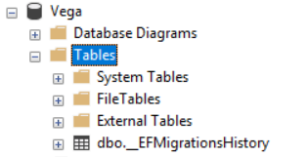

Now access class “Make” and do the following changes:

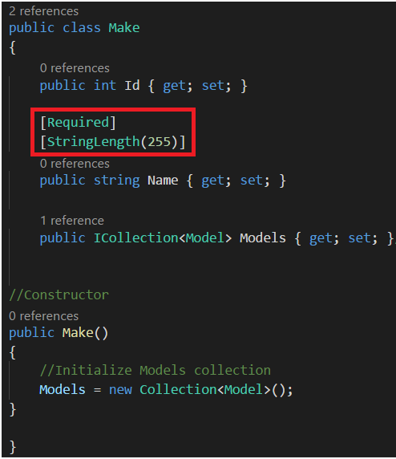

Also perform the same changes in class “Model”:

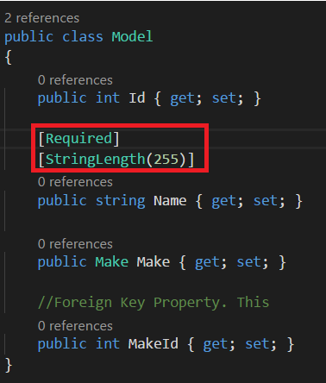

To correct the issue with the name of the table, enter the following in table “Model”:

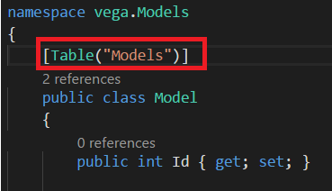

We have now make the necessary changes to correct our table. Now, we need to create a new Migration.



If you check the Migration file you will see the changes of the table:

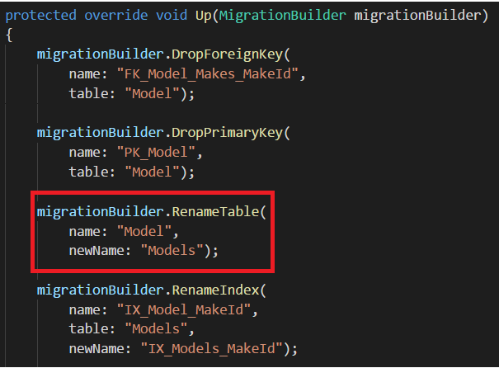

Now, Update the Database:



Check that everything has been corrected:

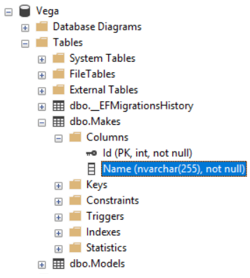

When it comes to Migrations, you should ALWAYS use Baby Steps.



So, you should make small changes to your Model and create a Migration. Because every time you create a migration, you should proper review it to make sure it doesn’t have an adverse effect on the database. If you make a big step and create a big domain model, you will end up with a gigantic migration. And that increase the chance for errors.

Now we need to pre-populate our Makes and Models table with data before you even think of using it. Because these tables are tables with Reference Data. It should be available in all environments (Development, Staging and Production).

So, you will want to use CodeFirst Migrations to populate these tables. With this technique, every time I deploy my application to a different machine, I can simply run all the Migrations and Entity Framework will populate it with the reference data. Start by creating an empty migration:



Now we have to write SQL statements in this Migration “SeedDatabase.cs” to populate these tables:

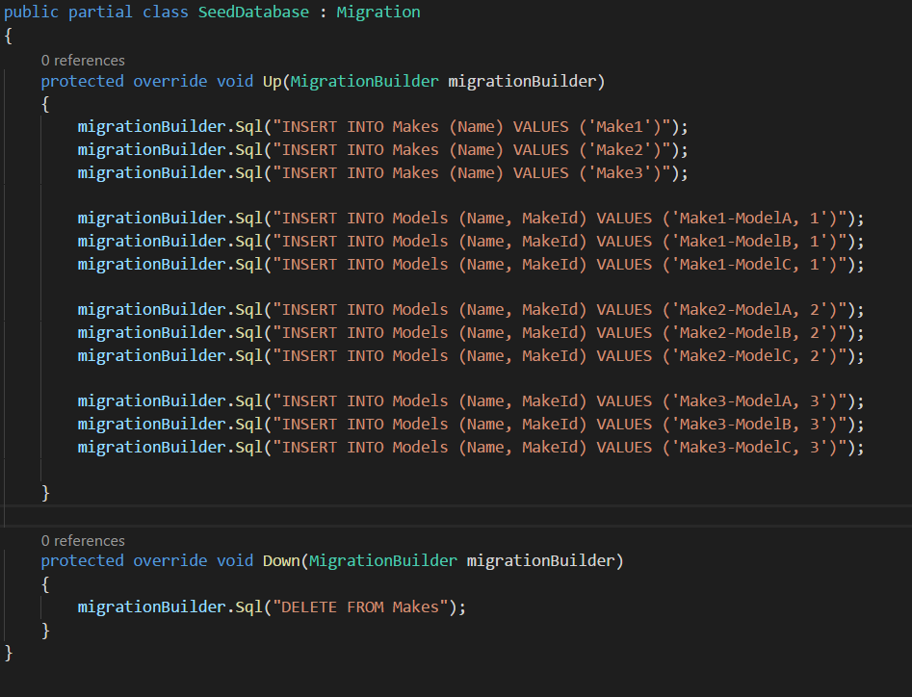

**Find that I have filled the Down method in case I need to downgrade my database and undo the Migration.**

Another important point here. The actual proper way to write the SQL statements would be a bit different. Check the following:

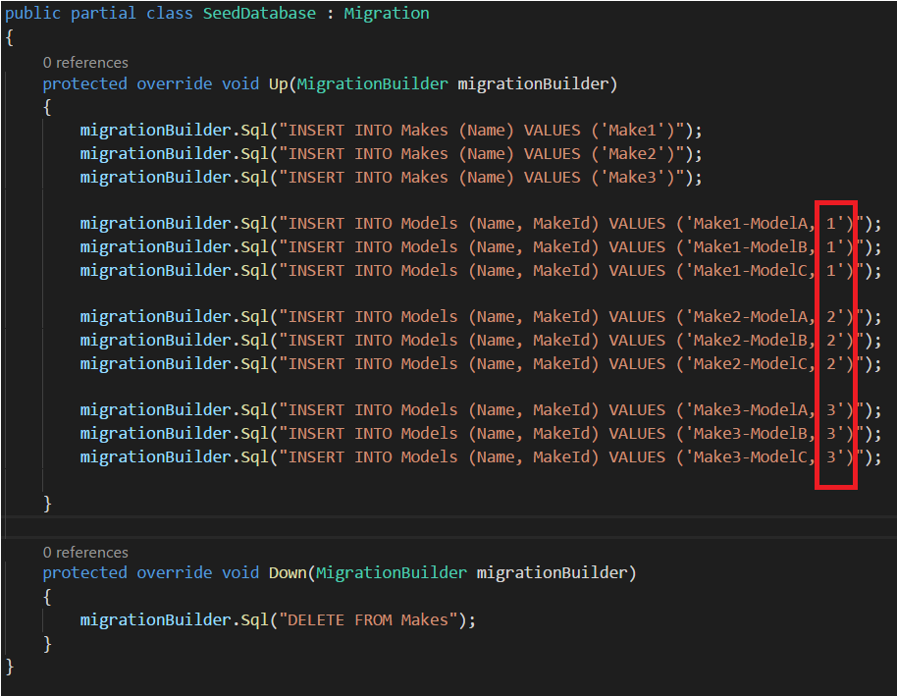

Imagine that I downgrade the Database. When I execute this file again and Seed the Database with this data, the Ids of the Makes are not going to be 1, 2 or 3. They are going to be 4, 5 and 6. That’s why the proper way to populate these tables is to select the MakeId instead of hardcoding it here. So, let’s do the correct way:

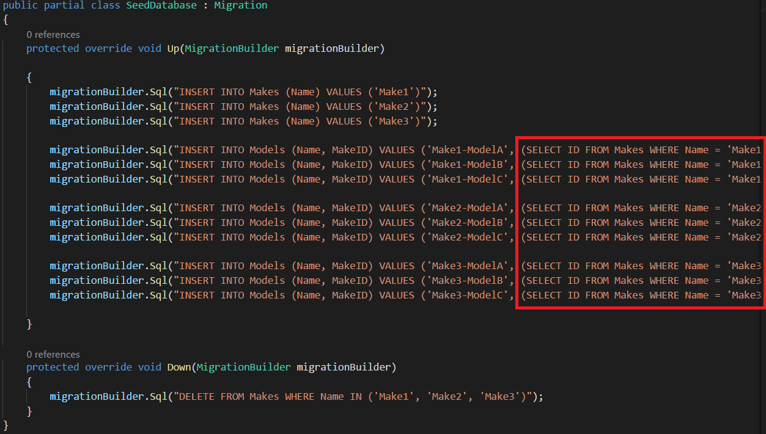

Now, update the Database with this data.



Now check these Database Tables:

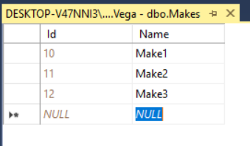

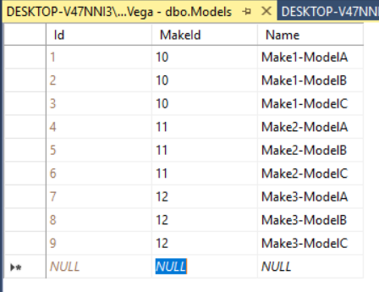

**Note that there’s an issue with table “Makes”. It started with ID 10, instead of 1. How to correct that?**



To correct this issue, I downgraded the Database and did the following corrections:

The real problem was that my Migration SQL Statement was wrong. I had this:

migrationBuilder.Sql("INSERT INTO Models (Name, MakeId) VALUES ('Make1-ModelA', (SELECT ID FROM Makes WHERE Name = 'Make1'))");

While I should have got this:

migrationBuilder.Sql("INSERT INTO Models (Name, MakeID) VALUES ('Make1-ModelA', (SELECT ID FROM Makes WHERE Name = 'Make1'))");

After downgrading everything, changing the SQL statement in the “SeedDatabase” file, and Updating the Database again, that’s what I got:

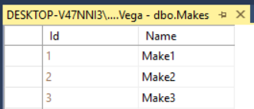

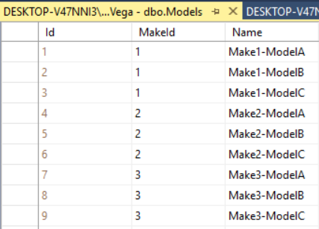

All good.

|  |
| --- |
| **11 – Building our First APIs** |

To start with, create a Controller “**MakesController**” under folder **Controllers**:

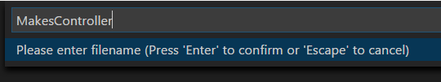

**Note that I use plural names for naming my Controllers**

In ASP.NET MVC 5, we had two types of Controllers: **Standard MVC Controller** (used for returning Views) and **API Controllers**. These Controllers and their related classes we defined into two different namespaces. And we also had two route configurations. One for MVC Controller and the other for API Controllers. In ASP.NET Core, both these two types of Controllers are consolidated into one Controller, like the one we’re using for our API Controller below.

Also, in the previous version of ASP.NET, we had this convention “if you called your method ‘**Get’** the framework would assume that this method is only accessible using **HTTP GET**”. However, this convention no longer applies in ASP.NET Core and we need to explicitly apply attribute **[HttpGet(“Endpoint”)]** in this method.

You will also notice that I’m using keywords **async** and **await**. **Async** and **Await** are nothing but markers. They mark code positions from where the control should resume after a task or a thread completes.

In Web applications, when we receive a request, runtime allocates a thread to handle that request. When it comes to I/O bound operations, like accessing a database, or a file, or network bound operations like calling a remote service, there’s always a delay. For example, in the case of accessing a database. This thread has to wait until the database executes the query and returns the result.

Since we have limited amount of memory and threads available in a web server, if you have a lot of concurrent users, at some point you may run out of threads because many of them are waiting for I/O bound or network bound operations to complete. In this case, we either need to add more hardware in terms of memory or more machines, or we can use **Async** and **Await**.

When we use Async, our thread will no longer wait for the database to return the result. It will be released so it can server other requests. A common misconception in the market is that this improves the performance of your app. It doesn’t, because it does not reduce the average response time. We still have to wait for the database to return the results. But during that wait period, our threads can be better utilized to serve more concurrent users, and this means better scalability, not performance.

This is our first Controller class:

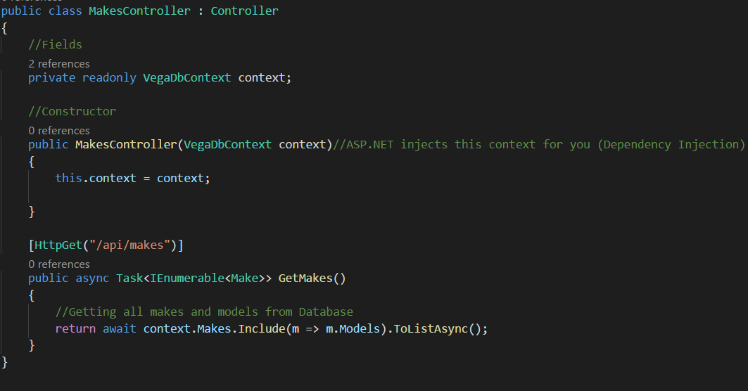

**Note that you’re using dependency injection that you have configured in class “Startup.cs”, method “ConfigureServices” as below:**



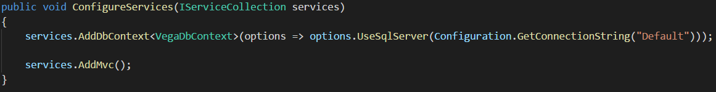

If you run your app:



And test this new API through URL:

<http://localhost:5000/api/makes>

You will find this:

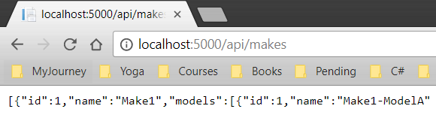

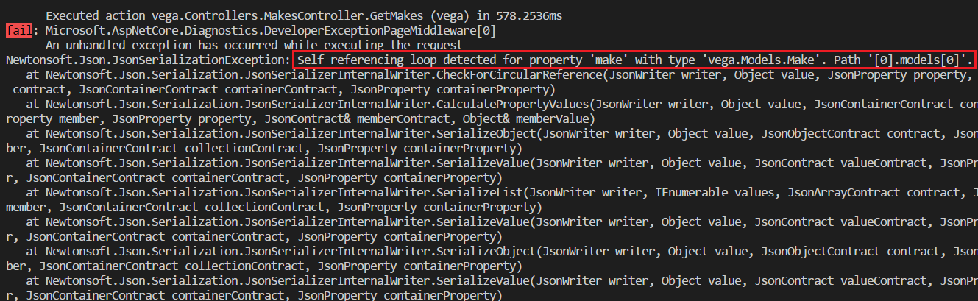

There’s a problem. There is a loop in your Model domain.

Each Make has a collection of Models, as below:

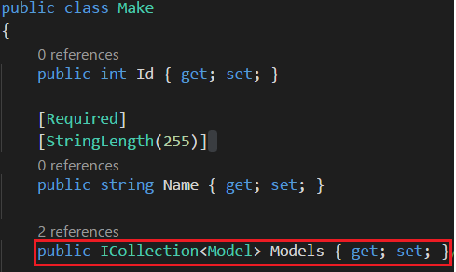

Also, each Model has a Make:

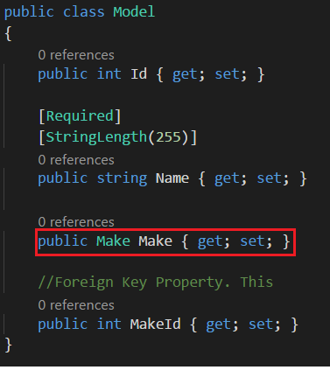

This causes a Loop. Because a Make object has 0 to many models. And each Model has one Make, which has 0 to many models and each Model has one Make, and this gets to the Loop.

This figure represents the loop:

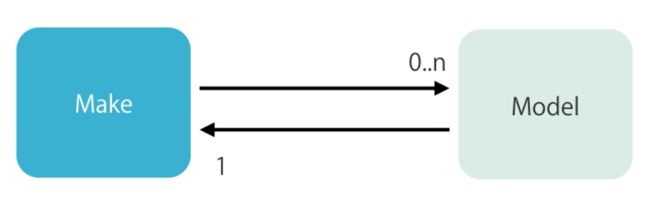

With this, we cannot properly serialize this into JSON. To fix this problem, we have to use AutoMapper solution. It’s also necessary to map the Domain classes into our Resource classes. For this we’re going to use Auto Mapper. For AutoMapper settings, refer to the Set Up Environment section.

To use the AutoMapper, access your MakesController and do these changes:



Also, enter the Mapping from Make to MakeRerources:



If you test your API now:



|  |
| --- |
| **12 – Common Runtime Errors** |

There are a couple of error that happen quite frequent one’s machine. Don’t know exactly the reason, but will show the workaround.

1 - Error: Cannot find module ‘aspnet-webpack’

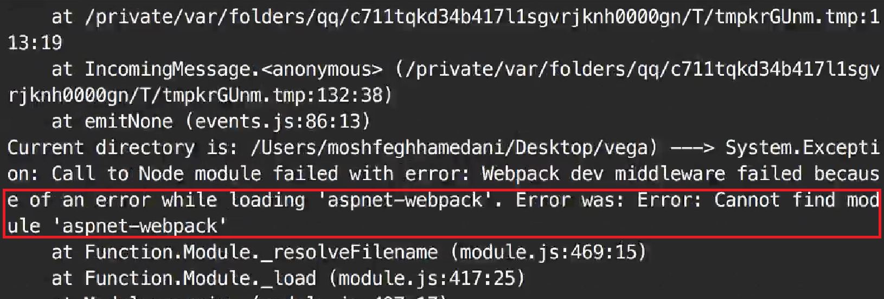

For some unknown reason, the “**node_modules**” disappear magically from your project. This may happen time to time.

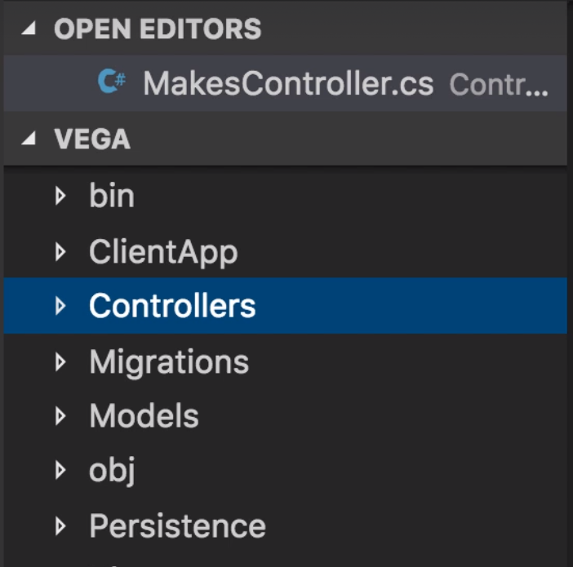

If you have this problem, the solution is:



2 - Error: Cannot find module ‘./wwwroot/dist/vendor-manifest.json’:

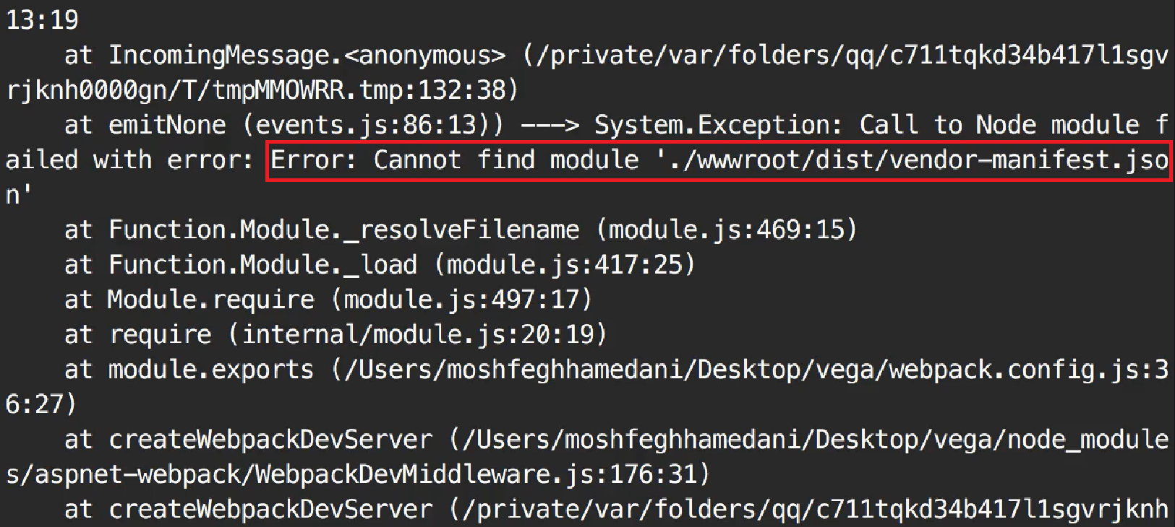

If you take a look at “wwwroot” folder, there is no “dist folder in there:

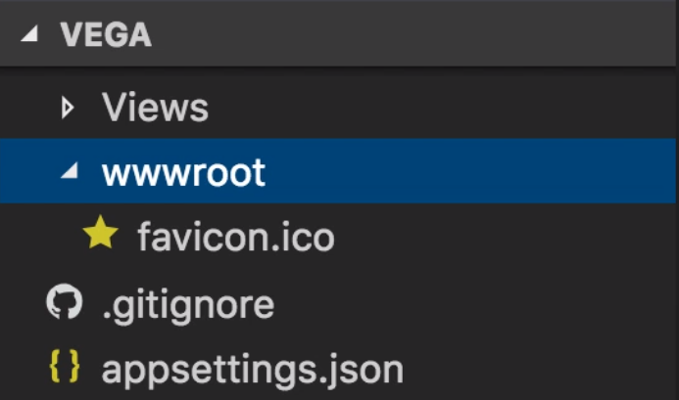

It magically disappears. To fix this, we need to run:



And finally create the main bundle:



|  |
| --- |
| **12 – Adding a New Angular Component** |

**Add a new Angular Component**

We’re going to start by creating a component in our Angular App. So, go to the terminal and type

**Attention Important**